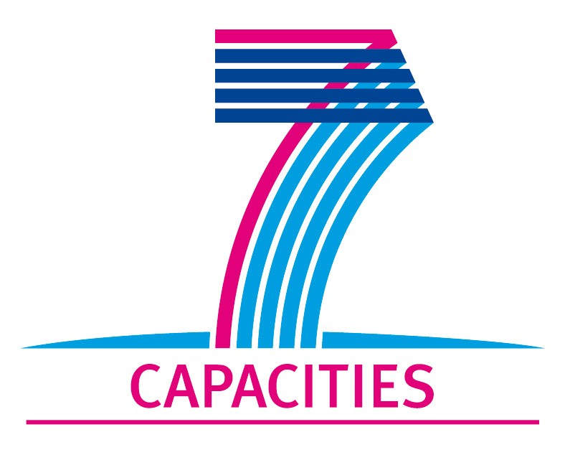

Application Form for MICROKELVIN Transnational Access Project

1. General Information

Project number: | AALTO13
Project Title: | Fabrication of nanoresonators for energy dissipation in superfluid 3He
Lead scientist: | Title: | Dr.
 | First name: | Vladimir
 | Last name: | Komanicky
 | Birth date: | 22.07.1974
 | Passport number: | BG8692823
 | Research status/Position: | Research scientist
 | New User: | yes
 | Scientific Field: | nanophysics
 | Home institution: | Safarik University
 | Is your home institution MICROKELVIN partner? | no
 | Business address:
 | Street: | Park Angelinum 9
 | PO Box:
 | City: | Kosice
 | Zip/Postal Code: | 04001
 | Country: | Slovakia
 | Telephone: | 00421552342300
 | Fax:
 | E-mail: | Vladimir.komanicky@upjs.sk
I obtained M.S. degree in electrochemistry under supervision of Prof. K. Markusova at Safarik University in Kosice, Slovakia. Shortly after, I pursued my doctoral degree at University of California in Davis under supervision of Prof. W. R. Fawcett and Prof. Gang-yu Liu. I successfully graduated with the Ph. D. degree in chemistry in 2003. After that, I worked several years as a postdoctoral scientist and visiting scientist in Materials Science Division in Argonne National Laboratory in group of Dr. H. You and Dr. N. Markovic, who specialize in the area of electrocatalysis and surface x-ray scattering.
Currently, I work at Safarik University in Kosice, where I have been establishing a new nanotechnology laboratory. The main focus of the laboratory is on the nanostructure fabrication by “top-down” methods for fundamental research in solid state physics, surface science and electrocatalysis.
 | Five most recent publications:
- Vladimir Komanicky, Hakim Iddir , Kee-Chul Chang, Andreas Menzel,, Goran Karapetrov, Daniel C. Hennessy, Peter Zapol, Hoydoo You, Fabrication and characterization of platinum nanoparticle arrays of controlled size, shape and orientation Electrochimica Acta (2010) 55, 7934.
- M. S. Pierce, K. C. Chang, D. Hennessy, V. Komanicky, M. Sprung, A. Sandy, H. You, Surface X-Ray Speckles: Coherent Surface Diffraction from Au(001) Physical Review Letters (2009), 103, 165501.

 | - V. Komanicky, H. Iddir, KC. Chang, A. Menzel, G. Karapetrov, D. Hennessy, P. Zapol H. You, Shape-Dependent Activity of Platinum Array Catalyst J. Am. Chem. Soc., (2009) 131(16), 5732-5733.
 | - D. S. Strmcnik, D. V. Tripkovic, D. Van Der Vliet, K. C. Chang, V. Komanicky, H. You, G. Karapetrov, J. P. Greeley, V. R. Stamenkovic, N. M. Marković Unique activity of platinum adislands in the CO electrooxidation reaction J. Am. Chem. Soc. (2008), 130(46) 15332.
 | - M. S. Pierce, KC. Chang, D. C. Hennessy, V. Komanicky, H. You, CO-induced lifting of Au(001) surface reconstruction J. Phys. Chem. C (2008), 112(7), 2231-2234.
Other participating scientists: | Name: |  | Position: | New User:2
 | 1- Dr. P. Skyba |  | Research scientist | no
 | 2-
 | 3-

2. Project Information

Name of host infrastructure: | Aalto University
Access provider / Infrastructure Director: | Name: Mikko Paalanen  Jukka Pekola |  | E-mail address:  paalanen@neuro.hut.fi  pekola@boojum.hut.fi
Planned project dates: | Visit: | 2 weeks in  May – June 2011 | more visits follow later depending on results
Project description (12 lines max):
Mechanical resonators have been used in thermometry in cryogenic fluids, generation and detection of quantum turbulence in superfluids and as a force sensors. When physical properties of resonator such as surface roughness or its dimensions are in the order of nanometers some interesting new phenomena can arise during energy dissipation processes in supefluid liquids. Identifying the main dissipation mechanisms in nanomechanical resonators is of fundamental importance. However, despite ongoing efforts over a number of years a complete understanding energy dissipation on micron and nanoscale mechanical resonators remains elusive. We will prepare resonators of different widths. We will study their resonance characteristics in liquid 3He depending on the width of the resonator.
Scientific objectives of the project (12 lines max):
The proposed project aims at promoting scientific collaboration and knowledge exchange between two European research institutions. A nanofabrication facilities at Aalto University will be used to fabricate nanoresonators, which will be tested at Safarik University. The scientific goal of the project is to study mechanical properties of nanoresonators and dissipation of energy at low and ultra low temperatures in cryogenic liquids. Skyba et. al recently showed that the force – velocity dependencies measured at corresponding resonance frequencies for the mezoscopic tuning forks in superfluid 3He-B shows interesting phenomena. While the dependence for the small fork clearly shows the “Andreev character” of the dependence i.e. a reduction of the damping force with increasing velocity, there is not such evidence in this dependence for the large and medium forks. Therefore we expect to see some new phenomena arising when the size of the resonators falls in the nanoscale regime.

Technical description of work to be performed (20 lines max):
The visitor (Dr. V. Komanicky) will fabricate free standing nanobridges from gold. Patterns in positive resists will be fabricated using e-beam lithography. We plan to fabricate bridges of different lenghts and widths. The mechanical properties of resonators will be tested at Safarik University using magnetomotive method.
1. Positive resist will be spincoated on substrates from GaAs or Silicon. Thickness of resist will be optimized.
2. Dose test of chosen resist will be performed and optimized parameters will be used in structure exposure by e-beam.
3. After development, 100 nm of gold will be deposited over resist and structures will be made by lift off process.
4. The bridges will be freed from the substrate by wet etching.
5. The resonators will be tested in the vacuum and cryogenic liquids from room temprature to 4K at Safarik University.

3. Joint Proposals / Funding

Is this project in collaboration with other (concurrent) projects at the infrastructure? No
If yes, please specify: GEOMDISS, EU FP7 FET Open strep project, where LTL participates

Is this proposal submitted to any funding programmes? No
If yes, please specify:

____________________
The completed Application Form should be submitted to MICROKELVIN Management Office (Katariina.Toivonen@neuro.hut.fi, fax +358-9-47022969)

The lead scientist indicated here is expected to participate in the campaign as a user of the infrastructure.
Indicate ’Yes’ only if the user has never visited the infrastructure before this specific project, otherwise write ’No’.
Please list all participating user group members. Expand the table, if necessary.

