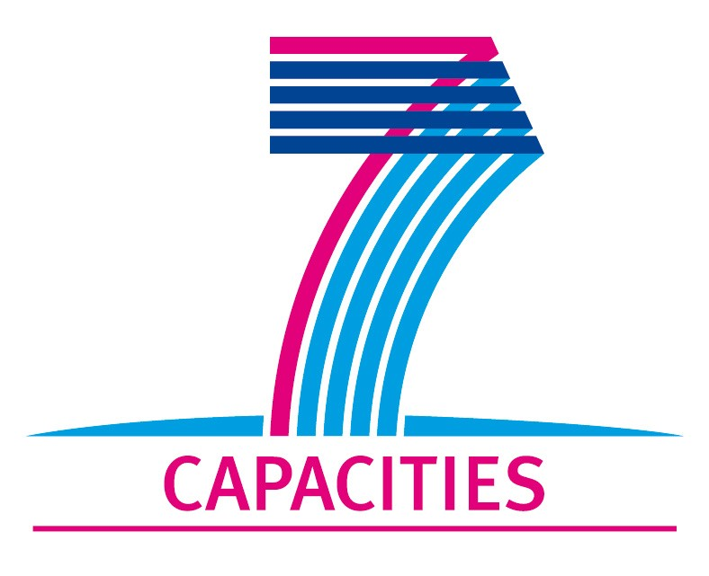

**Application Form for MICROKELVIN Transnational Access Project**

**1. General Information**

|  |  |  |  |  |
| --- | --- | --- | --- | --- |
| **Project number:** | CNRS06 | | | |
| **Project Title:** | **Micro- and nano- sensors for probing quantum turbulence** | | | |
| **Lead scientist:**[1] | **Title:** | **RNDr.** | | |
|  | **First name:** | **David** | | |
|  | **Last name:** | **Schmoranzer** | | |
|  | **Birth date:** | **November 28th, 1981** | | |
|  | **Passport number:** |  | | |
|  | **Research status/Position:** | **4th year graduate student, Low Temperature Department, Faculty of Mathematics and Physics, Charles University in Prague, Czech Republic** | | |
|  | **New User:**[2] | **No** | | |
|  | **Scientific Field:** | **Superfluidity, quantum turbulence** | | |
|  | **Home institution:** | **Charles University, Prague** | | |
|  | **Is your home institution MICROKELVIN partner?** | **No** | | |
|  | **Business address:** |  | | |
|  | Street: | **V Holesovickach 2** | | |
|  | PO Box: |  | | |
|  | City: | **Prague** | | |
|  | Zip/Postal Code: | **180 00** | | |
|  | Country: | **Czech Republic** | | |
|  | Telephone: | **+420 22191 2716, +420 777 586 939** | | |
|  | Fax: |  | | |
|  | E-mail: | **david.schmoranzer@gmail.com** | | |
|  | Curriculum vitae (18 lines max):  **Personalia:** born in Sumperk, Czech Republic, November 28th, 1981, single  **Education:** ***1996-2002:*** English Section of Gymnazium Olomouc-Hejcin, Czech Rep. (bilingual high school, all subjects taught in English); ***2002-present:*** Charles University in Prague, Czech Rep.; M.Sc. 2007 (Advisor: L. Skrbek, Master’s Thesis: Vibrating quartz crystal as a tool for studying the flow of cryogenic fluids ; Doctoral Thesis : Investigation of Cryogenic Helium Flows Using Mechanical Oscillators)  **Employment history:*****2004-2008:*** English <-> Czech translator, ATP CZ s.r.o. and Transnet s.r.o.; ***2006-2007:*** English -> Czech translator, Volvox Globator (publishing house); ***2008-present:*** Researcher, Charles University in Prague  **Scientific interest and activity:** Low temperature physics and fluid dynamics (classical and quantum turbulence, superfluidity, cryogenic fluid dynamics)  **Training, Courses, Stays abroad:** Cryoschool 2006, Dordrecht, Netherlands; Vortices and Turbulence at Very Low Temperature 2007, Udine, Italy; Workshop on Topics in Quantum Turbulence 2009, Trieste, Italy; Two MICROKELVIN projects 2009, 2010 in collaboration with LTL Aalto University, Finland  **Skills :**English (fluent), French (basic), versatile PC skills, occasional programming and webdesign, basic technical skills and electronics  **Gen. interests:** Physics, languages, skiing, cycling, piano, choir, aikido, Red Cross | | | |
|  | **Five most recent publications:** | | | |
|  | 1 - Schmoranzer D., Kráľová M., Pilcová V., Vinen W.F., Skrbek L.: Experiments relating to the flow induced by a vibrating quartz tuning fork and similar structures in a classical fluid, Phys. Rev. E, 81, 066316 (2010) | | | |
|  | 2 - Schmoranzer D., Rotter M., Šebek J., Skrbek L.: Experimental setup for probing a von Karman type flow of normal and superfluid helium, EFM Proc., , 304-309 (2009) | | | |
|  | 3 - Prchal J., Šantavá E., Schmoranzer D.: Spin-glass behavior of RNi1-xCuxAl compounds, Physica B, 404, 3056-3058 (2009) | | | |
|  | 4 - Blažková M., Schmoranzer D., Skrbek L., Vinen W. F.: Generation of turbulence by vibrating forks and other structures in superfluid He-4, Phys. Rev. B, 79, 054522 (2009) | | | |
|  | 5 - Blažková M., Schmoranzer D., Skrbek L.: On cavitation in liquid helium in a flow due to a vibrating quartz fork, Low Temp. Phys., 34, 298-307 (2008) | | | |
| **Other participating scientists:**[3] | **Name:** | | **Position:** | **New User:2** |
|  | 1- Ladislav Skrbek | | Professor, Head of the Low Temperature Department, Faculty of Mathematics and Physics, Charles University in Prague, Czech Republic | no |
|  | 2- | |  |  |
|  | 3- | |  |  |

**2. Project Information**

|  |  |  |  |  |
| --- | --- | --- | --- | --- |
| **Name of host infrastructure:** | **CNRS, Institut Néel, Grenoble** | | | |
| **Access provider / Infrastructure Director:** | **Name:**  **Dr. Henri Godfrin** | | **E-mail:**  **henri.godfrin@grenoble.cnrs.fr** | |
|  |  | |  | |
| **Planned project dates:** | **Start date:** | **01/05/2011** | **Completion date:** | **30/11/2011** |
| **Project description (12 lines max):**  After more than half a century since its beginnings, quantum turbulence and cryogenic flow dynamics in general is still a very interesting field of low temperature research that can provide insights not only into the behaviour of superfluids, but might also contribute to the understanding of classical turbulence. The most common experimental tools used in quantum turbulence are various oscillating bodies, such as wires, grids, spheres and tuning forks [1]. Due to the immense progress in microfabrication technologies in the recent years [2,3], it became possible to reduce the size of these sensors significantly, leading to new possibilities in experimental studies that may be performed with higher spatial and temporal resolution and higher sensitivity at very low temperatures. Using the microfabrication expertise available in Grenoble, we propose to develop such sensors to be used for later investigations in helium superfluids. We would like to use the available three months’ time for MICROKELVIN projects **for two separate visits - one lasting cca 6 weeks in May/June 2011 and another one of a similar duration in October/November 2011**. | | | | |
| **Scientific objectives of the project (12 lines max):**  We aim to develop and manufacture sensitive micro-oscillators for probing turbulence in cryogenic helium liquids, emphasizing usage in He superfluids at very low temperatures. Here, the sensitivity of small detectors can be exceptionally high because of the rapidly falling drag force due to thermal excitations and low intrinsic damping, while larger sensors may be hindered both by intrinsic damping and sound emission [4]. We propose sensors in the form of wires [5], cantilevers and spheres [6] ranging in size from millimetres down to hundreds of nanometres, including microspheres smaller than typical intervortex distances at the transition to turbulence in He II (about 20 μm), intended to resolve some of the details of this transition. These could also be used to study the structure and dynamics of vortex tangles created by larger objects (tuning forks, grids). Sensitive micro/nano oscillators resonating at MHz frequencies might also be well-suited to provide information about energy spectra of quantum turbulence and to measure its decay with high resolution. The produced devices are to be used to study quantum turbulence within a research project at the Charles University in Prague, as well as for future experiments performed on-site at CNRS Grenoble. | | | | |
| **Technical description of work to be performed (20 lines max):**  To make the above goals possible, the visiting user will first need to familiarize with microfabrication technologies and low-noise electronics needed to readout the sensors. With guidance from world class experts at CNRS, designs of these sensors will be put together and we will proceed with manufacturing the sensors using a combination of materials, such as quartz, silicon, ferromagnetics (possibly SmCo5) and superconductors (Nb, NbTi). The devices considered for manufacturing are oscillating wires [2,5], cantilevers, goal-post oscillators [7], microspheres [3], and possibly custom-made “tuning forks” of various sizes. The exact types of the final sensors will be selected from these in the course of the project.  [1] L. Skrbek, W. F. Vinen, *The use of vibrating structures in the study of quantum turbulence* in *Progress in Low Temperature Physics*, Vol. XVI, Chapter 4, ed. M. Tsubota, W.P. Halperin, Elsevier, Amsterdam (2009)  [2] E. Collin, J. Kofler, J.-S. Héron, O. Bourgeois, Yu. M. Bunkov, H. Godfrin: *Novel ”vibrating wire like” NEMS and MEMS structures for low temperature physics*, J. Low Temp. Phys. 158, 678 (2010)  [3] E. Collin, J. Kofler, S. Lakhloufi, S. Pairis, Yu. M. Bunkov, H. Godfrin: *Metallic coatings of microelectromechanical structures at low temperatures: Stress, elasticity, and nonlinear dissipation,* J. Applied Phys. 107, 114905 (2010)  [4] D. Schmoranzer, M. La Mantia, G. Sheshin, I. Gritsenko, A. Zadorozhko, M. Rotter, L. Skrbek: *Acoustic emission by quartz tuning forks and other oscillating structures in cryogenic 4He fluids*, accepted to J. Low Temp. Phys.  [5] E. Collin, L. Filleau, T. Fournier, Yu. M. Bunkov, H. Godfrin: *Silicon Vibrating Wires at Low Temperatures*, J. Low Temp. Phys.150, 739 (2008) and 157, 566 (2009)  [6] M. Niemetz, W. Schoepe: *Stability of laminar and turbulent flow of superfluid 4He at mK temperatures around an oscillating microsphere*, J. Low Temp. Phys. 135, 447-469 (2004)  [7] E. Collin, T. Moutonet, J.-S. Heron, O. Bourgeois, Yu.M. Bunkov, H. Godfrin: *A tunable hybrid electro-magnetomotive NEMS device for low temperature physics*, QFS 2010 Grenoble, J. Low Temp. Phys., accepted (2010) | | | | |

**3. Joint Proposals / Funding**

|  |
| --- |
| **Is this project in collaboration with other (concurrent) projects at the infrastructure?  No** |
| **If yes, please specify:** |

|  |
| --- |
| **Is this proposal submitted to any funding programmes?**  **No** |
| **If yes, please specify:** |

*____________________*

1. The lead scientist indicated here is expected to participate in the campaign as a user of the infrastructure.
2. Indicate ’Yes’ only if the user has never visited the infrastructure before this specific project, otherwise write ’No’.
3. Please list all participating user group members. Expand the table, if necessary.