

Travel Form for MICROKELVIN Networking Activities

Travel Information
Reason for Travel (example: "Microkelvin Meeting")
Departing from (should be your usual working place):
Town:
Country:
Destination
Town:
Country:
Departure information
date: (dd/mm/yy)
time:
Return information
date: (dd/mm/yy)
time:
Transportation information (Air, bus, train…)
Traveler Information
Title:
First name:
Last name:
Birth date:
Nationality
Passport number:
For French only: N° Sécurité Sociale:
Research status/Position:
Home institution:
Is your home institution a MICROKELVIN partner?
Work address:
Street:
PO Box:
City:
Zip/Postal Code:
Country:
Telephone:
Fax:
E-mail:
Personal address:
Street:
PO Box:
City:
Zip/Postal Code:
Country:
Telephone:

Provide the following documents before departure | Copy of Passport or ID; banking ID form (see next page) ; if possible, copy of Banking ID document (for French only : include a copy of RIB)
After traveling | Original tickets, travel agency receipt or e-ticket indicating the price of the flight, flight coupons, hotel bills.

Banking Information of the traveler

Complete next page

Before Travel:
Send the completedforms by e-mail to henri.godfrin@grenoble.cnrs.fr

After Travel:
Send the Original tickets, flight coupons, hotel bills by regular mail to
Henri Godfrin
Microkelvin Networking Activities
CNRS-Institut Néel-MCBT-UBT
25 Rue des Martyrs - Bât. E-413
BP 166 38042 Grenoble Cedex 09
France

Phone : +33 (0)4 76 88 90 63
Fax : +33 (0)4 56 38 70 87

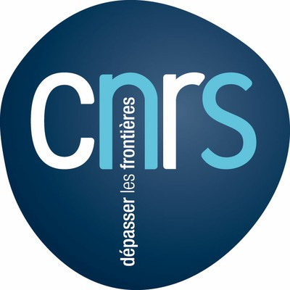
CENTRE NATIONAL DE LA RECHERCHE SCIENTIFIQUE
Délégation ALPES – Service Financier et Comptable

FICHE CREATION FOURNISSEUR OU AGENT / CREATION OF A SUPPLIER

RAISON SOCIALE OU NOM /NAME

TVA Intracommunautaire/VAT number (European Union only)
N° INSEE ou date de naissance/ birth date :
COORDONNEES PERSONNELLES / PERSONAL ADDRESS
Numéro de Rue / Boîte postale
Rue Street
Code Postal Zip Code
Ville City
Pays Country
Téléphone / Phone
Télécopie / Fax
E-mail comptabilité / accountant e-mail
E-mail commercial / commercial e-mail

COORDONNEES BANCAIRES / BANKING INFORMATION
Nom de la Banque/ Name of the bank
Adresse de la Banque / Address of the bank
Numéros de comptes / Account Number
IBAN (obligatoire CEE)
BIC SWIFT (obligatoire CEE)
ABA (hors CEE)

BANQUE INTERMEDIAIRE / INTERMEDIAIRE BANK
Nom de la Banque/ Name of the bank
Adresse de la Banque / Address of the bank
Numéros de comptes / Account Number
IBAN (obligatoire CEE)
BIC SWIFT (obligatoire CEE)
ABA (hors CEE)

Cachet commercial / commercial seal | Signature pour un missionnaire

