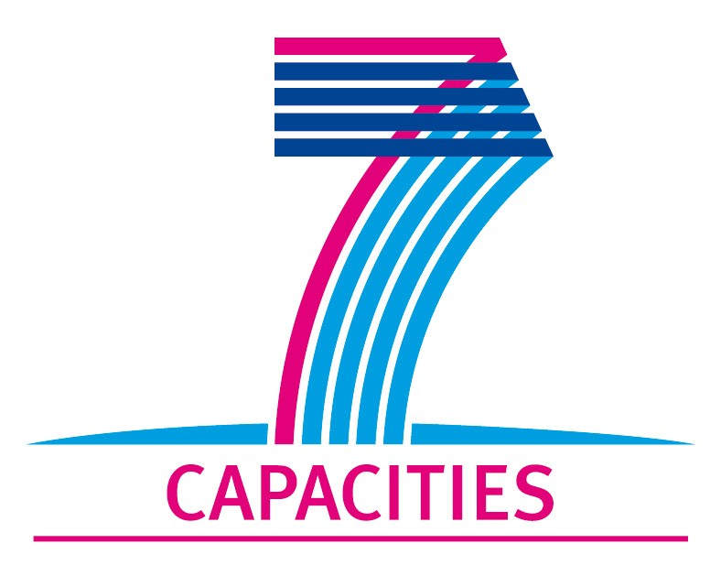

Application Form for MICROKELVIN Transnational Access Project

1. General Information

Project number:
Project Title:
Lead scientist: | Title:
 | First name:
 | Last name:
 | Home institution:
Host scientist: | Title:
 | First name:
 | Last name:
 | Home institution:
Project scientist: | Title:
 | First name:
 | Last name:
 | Scientific Field:
 | Home institution:
 | Is your home institution MICROKELVIN partner?
 | Business address:
 | Street:
 | PO Box:
 | City:
 | Zip/Postal Code:
 | Country:
 | Telephone:
 | Fax:
 | E-mail:
Curriculum vitae (18 lines max):
-
-
-
-
-
-
-
-
-
-
-
-
-
-
 | Five most recent publications:
 | 1-
 | 2-
 | 3-
 | 4-
 | 5-
Other participating scientists: | Name: |  | Position: | New User:
 | 1-
 | 2-
 | 3-
2. Project Information

Name of host infrastructure:
Access provider / Infrastructure Director: | Name: |  | E-mail address:
Planned project dates: | Start date: | [dd/mm/yyyy] | Completion date: | [dd/mm/yyyy]
Project description (12 lines max):
-
-
-
-
-
-
-
-
-
-
-
-
Scientific objectives of the project (12 lines max):
-
-
-
-
-
-
-
-
-
-
-
-
Technical description of work to be performed (20 lines max):
-
-
-
-
-
-
-
-
-
-
-
-
-
-
-
-

3. Joint Proposals / Funding

Is this project in collaboration with other (concurrent) projects at the infrastructure? Yes No
If yes, please specify:

Is this proposal submitted to any funding programmes? Yes No
If yes, please specify:

____________________
The completed Application Form should be submitted to MICROKELVIN Management Office (Sari.Laitila@aalto.fi, fax +358-9-47022969)

The lead scientist indicated here is expected to participate in the campaign as a user of the infrastructure.
The host scientist is supervising the work of the visiting project scientist at the infrastructure.
The project scientist is the person who will be visiting the infrastructure.
Please list all participating user group members. Expand the table, if necessary.

