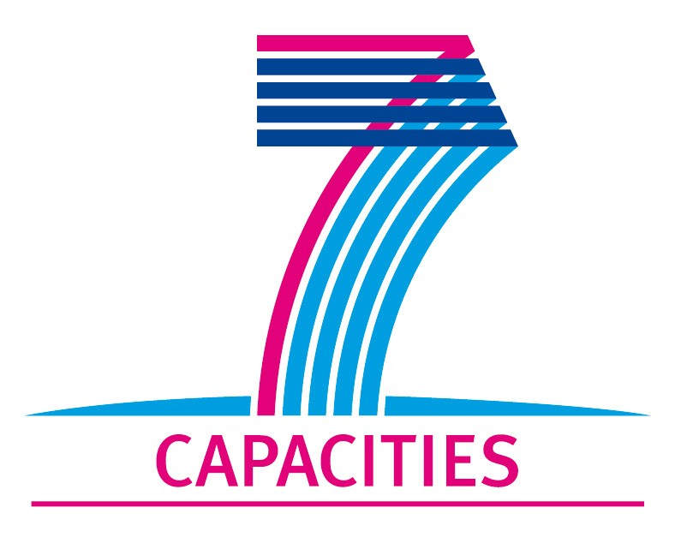

Report on the Transnational Access Activity carried out within MICROKELVIN

The eligibility of transnational access to a MICROKELVIN TA site implies the submission of the following:

- The Certification of visit
The form “Certification of visit” must be completed and signed by the access provider in charge of the infrastructure and the leader of the project.

- A TA project report
The form for the TA project report is contained within this document. It should be completed after project end by the group leader of the project. You must respect the limited number of words specified, longer descriptions will be rejected. Figures/tables may be attached at the end of the document. The document must be submitted in an editable format (doc, rtf).

- A User group questionnaire
To enable the Commission to evaluate the Research Infrastructures Action, to monitor the individual contracts, and to improve the services provided to the scientific community, each project leader of a user-project supported under an EC Research Infrastructure contract is requested to complete a "user group questionnaire". The questionnaire must be submitted once by each user group to the Commission as soon as the experiments on the infrastructure come to end.
The user group questionnaire is not part of this document and must be completed on-line. It is accessible at:
http://cordis.europa.eu/fp7/capacities/questionnaire_en.html.

_______________
► Please note that any publications resulting from work carried out under the MICROKELVIN TA activity must acknowledge the support of the European Community:
“The research leading to these results has received funding from the European Community’s Seventh Framework Programme (FP7/2007-2013) under grant agreement n° 228464 (MICROKELVIN).”
.

MICROKELVIN Transnational Access Project Report

1. General information

Project number:
Project Title:
Lead scientist: | Title:
 | First name:
 | Last name:
 | Home institution:
Host scientist: | Title:
 | First name:
 | Last name:
 | Home institution:
Project scientist: | Title:
 | First name:
 | Last name:
 | Birth date:
 | Passport number:
 | Research status/Position:
 | New User:
 | Scientific Field:
 | Home institution:
 | Is your home institution MICROKELVIN partner? | Yes No
 | Business address:
 | Street:
 | PO Box:
 | City:
 | Zip/Postal Code:
 | Country:
 | Telephone:
 | Fax:
 | E-mail:

2. Project information

Please, give a brief description of project objectives:
(250 words max)
Technical description of work performed:
(250 words max)
Project achievements (and difficulties encountered):⁵
(250 words max)
Expected publications and dates:
Submission date of user group questionnaire:

Completed Project Reports should be returned to MICROKELVIN Management Office
(Sari.Laitila@aalto.fi, Fax: +358 9 47022969).

The lead scientist indicated here is expected to participate in the campaign as a user of the infrastructure.
The host scientist is supervising the work of the visiting project scientist at the infrastructure.
The project scientist is the person who will be visiting the infrastructure.
Indicate ’Yes’ only if the user has never visited the infrastructure before this specific project, otherwise write ’No’.

