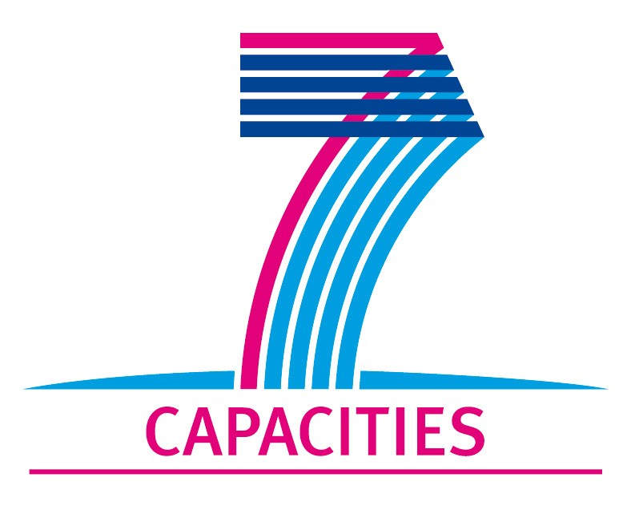

JRA3 Report #1
Name of the activity (work package): Attacking fundamental physics questions by microkelvin condensed-matter experiments
Reporting Period: from 1.4. 2009 to 30.9. 2009
Activity leader: Henri Godfrin

Table of expected deliverables on the reporting period
- Extract the expected deliverables of your work package from the list below. The table is cumulative and it should always show the all deliverables from the beginning of the project.

Expected milestones on the reporting period
- Extract the expected milestones of your work package from the list below

Summary
- A short summary of progress towards objectives and details for each task as presented in Annex 1 (Description of Work);

Highlights
- Highlight clearly significant results;

Reports:
- Deliverables that are of a nature other than written “reports”, such as “prototypes”, “demonstrator”, of “others” should be also accompanied by a short report, so that the European Commission has a record of their existence.

Deviations from work plan
- If applicable, explain the reasons for deviations from Annex I and their impact on other tasks as well as on available resources and planning;
- If applicable, explain the reasons for failing to achieve critical objectives and/or not being on schedule and explain the impact on other tasks as well as on available resources and planning (the explanations should be coherent with the declaration by the project coordinator) ;

Use of resources
- a statement on the use of resources, in particular highlighting and explaining deviations between actual and planned person-months per work package and per beneficiary in Annex 1 (Description of Work, the table of person-months below);
- If applicable, propose corrective actions.

List of Deliverables – to be submitted for review to EC

Del.no. | Deliverable name | WP no. | Lead beneficiary | Estimated person months | Nature | Dissemination  level | Delivery date
D1 | Report on microfabricated silicon vibrating wires tested in superfluid 3He at 100 μK | JRA3 | CNRS | 3 | R | PU | 12
D2 | Publication on vortex creation in superfluid 3He | JRA3 | ULANC | 20 | R | PU | 24, 36
D3 | Publication on 2D defects | JRA3 | ULANC | 18 | R | PU | 36
D4 | Publication on Black Holes | JRA3 | TKK | 12 | R | PU | 36
D5 | Publication on Q-balls in superfluid ³He | JRA3 | CNRS | 9 | R | PU | 48
D6 | Report on ULTIMA multicell particle-detector operating underground | JRA3 | CNRS | 16 | R | PU | 48

List and schedule of milestones
Milestone number | Milestone name | WPs no’s | Lead beneficiary | Delivery date  From Annex I | Comments
M2 | Measurement of the dissipation when a vortex tangle is established | JRA3, Task 1 | ULANC | 24 | Report
M3 | A precise determination of the effect of pressure on vortex creation via the dynamics of the second-order phase transition | JRA3, Task 1 | ULANC | 30 | Report
M4 | Identification of the topological defects left after brane (phase boundary) annihilation | JRA3, Task 2 | ULANC | 24 | Report
M5 | Observation of several “cosmological defects” obtained in a microkelvin multi-cell detector | JRA3, Task 2 | ULANC | 30 | Test completed
M6 | Realization of a Black-Hole analogue in a rotating system with an A-B boundary | JRA3, Task 3 | TKK | 24 | Report
M7 | Test of the Unruh effect from rapid motion of a phase boundary | JRA3, Task 3 | TKK | 30 | Test completed
M8 | Test of the percolation theory of the A-B transition | JRA3, Task 3 | TKK | 36 | Test completed
M9 | The observation of the interaction between two independent precessing Q-balls | JRA3, Task 4 | CNRS | 30 | Report
M10 | Creation of excited modes of a “Q-ball” under radial squeezing by rotation | JRA3, Task 4 | CNRS | 36 | Test completed
M11 | Realization of microkelvin thermometry based on "Q-ball” behaviour | JRA3, Task 4 | CNRS | 42 | Report
M12 | Microfabricated silicon vibrating wires tested in superfluid ³He below 100 μK in underground laboratory conditions | JRA3, Task 5 | CNRS | 30 | Prototype functioning flawlessly
M13 | Superfluid ³He microkelvin underground multicell particle-detector operating underground | JRA3, Task 5 | CNRS | 42 | Prototype running flawlessly

Person-months per beneficiary per WP for 1.4. 2009 - 31.3. 2013
Participant no./short name | NA1 | NA2 | NA3 | NA4 | JRA1 | JAR2 | JRA3 | JRA4 | Total person months
1. TKK | 20 | 1 |  |  | 8 | 32 | 12 | 6 | 79
2. CNRS |  | 1 | 2 | 1 | 16 | 12 | 18 | 12 | 62
3. ULANC |  | 1 |  | 1 | 16 |  | 26 |  | 44
4. HEID |  |  |  |  |  |  | 10 | 27 | 37
5. RHUL |  |  |  |  | 4 | 9 | 4 | 30 | 47
6. SNS |  |  |  |  |  | 18 |  |  | 18
7. SAS |  |  |  |  | 8 |  | 8 |  | 16
8. BASEL |  |  |  |  | 18 | 9 |  | 10 | 37
9. DELFT |  |  |  |  |  | 15 |  |  | 15
10. BLUEFORS |  |  |  |  | 10 |  |  |  | 10
11. UL |  |  |  |  | 4 |  |  | 12 | 16
12. PTB |  |  |  |  |  |  |  | 8 | 8
Total | 20 | 3 | 2 | 2 | 84 | 95 | 78 | 105 | 389

