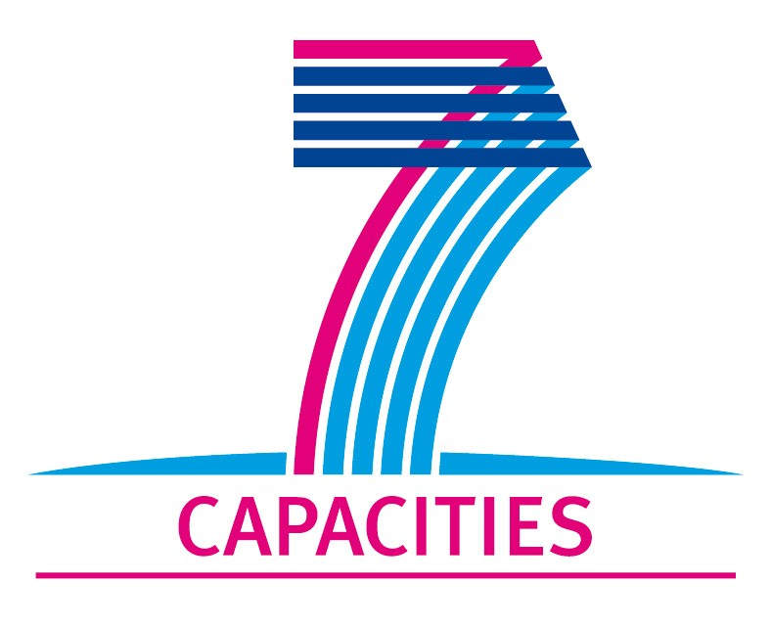
Application Form for MICROKELVIN Transnational Access Project

1. General Information
Project number: | AALTO14
Project Title: | Vortex front propagation and the axially moving transition from the vortex-free Landau state to the equilibrium vortex state
Lead scientist: | First name: | Victor
Lead scientist: | Last name: | L’vov
Lead scientist: | Birth date:
Lead scientist: | Research status/Position: | Prof.
Lead scientist: | New User: | No
Lead scientist: | Scientific Field: | Turbulence in helium superfluids
Lead scientist: | Home institution: | Weizmann Institute of Science, Rehovot, Israel
Lead scientist: | Home institution is MICROKELVIN partner: | No
Lead scientist: | Business address: | Weizmann Institute of Science
Lead scientist: | Street:
Lead scientist: | Street No.:
Lead scientist: | PO Box:
Lead scientist: | City: | Rehovot
Lead scientist: | Zip/Postal Code: | 76100
Lead scientist: | Country: | Israel
Lead scientist: | Telephone: | +972(8)9343750
Lead scientist: | Fax: | +972(8)9344123
Lead scientist: | E-mail: | Victor.Lvov@gmail.com  http://lvov.weizmann.ac.il
Lead scientist: | Curriculum vitae (18 lines max):  Prof. L’vov is a senior member of the permanent staff at the Weizmann Institute and a widely known expert of hydrodynamic theory in both viscous and superfluid flow. He comes from the Institute of Automization in Novosibirsk (Russian Academy of Sciences) from where he moved to the Weizmann Institute in the early nineties.
Lead scientist: | Five most recent publications (on helium superfluids):
Lead scientist: | V.S. L'vov, S.V. Nazarenko, and O. Rudenko, Bottleneck crossover between classical and quantum superfluid turbulence, Phys. Rev. B 76, 024520 (2007). DOI: 10.1103/PhysRevB.76.024520
Lead scientist: | V. S. L'vov, S. V. Nazarenko, and O. Rudenko, Gradual eddy-wave crossover in superfluid turbulence, J. of Low Temp. Phys. 153, 140-161 (2008). DOI:s10909-008-9844-0
Lead scientist: | V.S. L’vov, Anna Pomyalov, I. Procaccia, and O. Rudenko, Finite-dimensional turbulence of planetary waves, Phys. Rev. E 80, 066319 (2009) – Published December 30, 2009.
Lead scientist: | V.B. Eltsov, R. de Graaf, R. Hanninen, M. Krusius, R.E. Solntsev, V.S. L'vov, A.I. Golov, and P.M. Walmsley,Turbulent dynamics in rotating helium superfluids, Progress in Low Temperature Physics, XVI pp. 46-146 (2009), DOI:0.1016/S0079-6417(08)00002-4 ; arXiv:0803.3225
Lead scientist: | J. Laurie, V.S. L’vov, S. Nazarenko, and O. Rudenko, Interaction of Kelvin waves and nonlocality of energy transfer in superfluids, Phys. Rev. B 81, 104526 (2010) – Published March 26, 2010.
Lead scientist: | V. S. L’vov and S. Nazarenko, Discrete and mesoscopic regimes of finite-size wave turbulence, Phys. Rev. E 82, 056322 (2010) – Published November 19, 2010.
Lead scientist: | V.S. L’vov and S.V. Nazarenko, Spectrum of Kelvin-wave turbulence in superfluids, Pis’ma v ZhETF 91, 464 (2010) ; arXiv :0911.2065v5
Lead scientist: | V. L’vov and S. Nazarenko, Comment on “Superfluid Turbulence from Quantum Kelvin Wave to Classical Kolmogorov Cascades” , Phys. Rev. Lett. 104, 219401 (2010) – Published May 25, 2010.
Lead scientist: | V. B. Eltsov, R. de Graaf, P. J. Heikkinen, J. J. Hosio, R. Hänninen, M. Krusius, and V. S. L’vov, Stability and Dissipation of Laminar Vortex Flow in Superfluid ³He-B , Phys. Rev. Lett. 105, 125301 (2010) – Published September 14, 2010.
Other participating scientists: | Name: |  | Position: | New User:²
Other participating scientists: | 1 - Sergey V. Nazarenko |  | professor  University of Warwick, UK | yes
Other participating scientists: | 2 - Oleksii Rudenko |  | post-doctoral researcher  Technische Universiteit, Eindhoven, Netherlands | yes

2. Project Information

Name of host infrastructure: | Low Temperature Laboratory, Aalto University, Espoo, Finland
Access provider / Infrastructure Director: | Name: Prof. Matti Krusius  Prof. Grigory Volovik |  | E-mail address: mkrusius@neuro.hut.fi  volovik@boojum.hut.fi
Access provider / Infrastructure Director: | Prof. Mikko Paalanen |  | paalanen@neuro.hut.fi
Planned project dates: | Start date: | 29/7/2011 | Completion date: | 29/8/2011
Project description (12 lines max):
The dynamics of quantized vortices at the very lowest temperatures is a central topic in the Microkelvin programme (Joint Research Activity package 3 Task 1 – Investigation of quantum vortices as model cosmic strings). One of the challenges is to understand the sources of dissipation in vortex motion at the lowest temperatures in the limit T → 0. This is the regime in which the motion of cosmic strings could be expected to take place today, if they are found to exist.
At higher temperatures dissipation is caused by the damping in vortex motion known as mutual friction. It arises from the scattering of normal excitations from a vortex which moves with respect to the reference frame provided by the normal fluid. Mutual friction dissipation vanishes as the density of normal excitations approaches zero. However, currently it is believed that in turbulent vortex motion dissipation does not appear to extrapolate to zero in the T → 0 limit. Are there thus new mechanisms which govern superfluid dynamics at the lowest temperatures?
One of the phenomena which have been employed for such studies is the motion of a vortex front axially along a long rotating cylinder. Here the front divides the cylinder in a region of vortex-free rotating counterflow ahead of the front and the region behind the front with vortices at a solid-body-rotation density. Measurements of the azimuthally rotating and axially advancing front have been performed since 2005 in the rotating cryostat of the Low Temperature Laboratory with the fermion superfluid 3He-B. The first results [1] on the axial velocity of the front were obtained with NMR techniques and were interpreted assuming that the dissipation is primarily produced by the turbulent front motion. Subsequent thermal studies [2] of the axially moving transition from vortex-free counterflow to the rotating equilibrium vortex state (at constant rotation velocity Ω) showed that with decreasing temperature in the limit T → 0 an increasing fraction of the total dissipation is incurred by laminar vortex flow. Although this result was opposite to what was generally expected, it is consistent with measurements of the spin-down response [3] of the equilibrium vortex state after a sudden stop of the rotation drive.
References:
[1] V.B. Eltsov, A.I. Golov, R. de Graaf, R. Hänninen, M. Krusius, V.S. L’vov, and R.E. Solntsev, Quantum turbulence in a propagating superfluid vortex front; Phys. Rev. Lett. 99, 265301 (2007).
[2] V.B. Eltsov, R. de Graaf, J.J. Hosio, P.J. Heikkinen, R. Hanninen, M. Krusius, V.S. L'vov, and G.E. Volovik, Laminar and turbulent dissipation in superfluid vortex front motion below 0.3Tc, preprint arXiv:1102.4284 (2011).
[3] V.B. Eltsov, R. de Graaf, P.J. Heikkinen, J.J. Hosio, R. Hänninen, M. Krusius, and V.S. L’vov, Stability and dissipation of laminar vortex flow in superfluid 3He-B, arXiv:1005.0546v1, Phys. Rev. Lett. 105, 125301 (2010).

Scientific objectives of the project (12 lines max):
At present there are thus major unresolved questions concerning the correct interpretation of the different dynamic measurements at the lowest temperatures. Clearly the dynamics should be understood better if we ever want to make use of the helium superfluids as laboratory model systems of coherent quantum matter in the vacuum T → 0 limit.
Prof. L’vov has studied extensively the decay of homogeneous and isotropic superfluid turbulence via the Richardson – Kolmogorov hydrodynamic energy cascade which ultimately at sufficiently low mutual friction dissipation and small length scales (comparable to the inter-vortex distance) couples to Kelvin waves propagating on single vortex lines. It is important to understand to how these theories apply to the propagating vortex front. New results are currently accumulated both in laboratory measurements as well as in high-resolution numerical calculations on the axial velocity and the azimuthal precession of the propagating vortex front as a function of temperature and rotation velocity. This data is expected to provide a better understanding about the consistency between measurement and calculation and hopefully ultimately about the mechanisms which control the axially propagating transition from the vortex-free Landau state to the equilibrium vortex state.
Technical description of work to be performed (20 lines max):
During his 1-month visit in the Low Temperature Laboratory, prof. L’vov will follow and participate in new measurements on the propagating vortex front. Here the axial velocity of the front is measured with cw NMR techniques as a function of temperature (T) and rotation velocity (Ω) in the T → 0 limit. The goal is to work out an adequate understanding of the dynamics in the regime where the superfluid component starts to lose its coupling to the rotating reference frame of the container walls.

3. Joint Proposals / Funding

Is this project in collaboration with other (concurrent) projects at the infrastructure? Yes
Specify: Quantum turbulence in the zero temperature limit

Is this proposal submitted to any funding programmes? No
If yes, please specify: None

____________________
The completed application form should be submitted to the MICROKELVIN Management Office

The lead scientist indicated here is expected to participate in the campaign as a user of the infrastructure.
Indicate ’Yes’ only if the user has never visited the infrastructure before this specific project, otherwise write ’No’.
Please list all participating user group members. Expand the table, if necessary.

