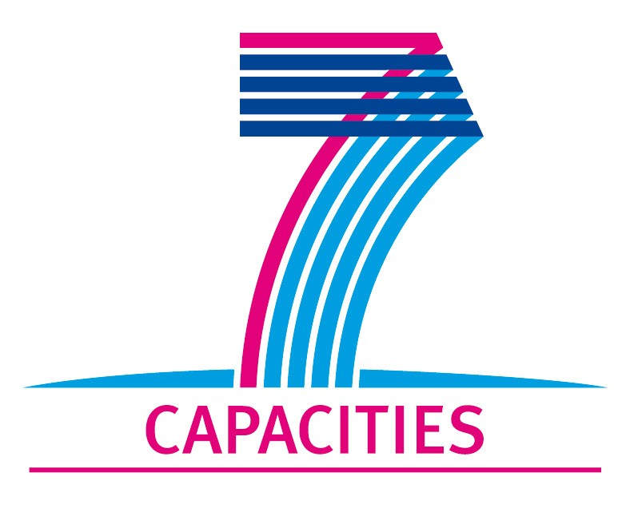
Application Form for MICROKELVIN Transnational Access Project

1. General Information
Project number: | AALTO15
Project Title: | Dynamics of quantized vortices in superfluids & superconductors
Lead scientist: | First name: | Edouard
Lead scientist: | Last name: | Sonin
Lead scientist: | Birth date:
Lead scientist: | Research status/Position: | Prof.
Lead scientist: | New User: | No
Lead scientist: | Scientific Field: | Condensed matter physics
Lead scientist: | Home institution: | Racah Institute of Physics,  Hebrew University of Jerusalem
Lead scientist: | Home institution is MICROKELVIN partner: | No
Lead scientist: | Business address:
Lead scientist: | Street: | Givat Ram
Lead scientist: | Street No.:
Lead scientist: | PO Box:
Lead scientist: | City: | Jerusalem
Lead scientist: | Zip/Postal Code: | 91904
Lead scientist: | Country: | Israel
Lead scientist: | Telephone: | +972-2-6586164
Lead scientist: | Fax:
Lead scientist: | E-mail: | sonin@cc.huji.ac.il
Lead scientist: | Curriculum vitae (18 lines max):  Edouard Sonin is a Professor Emeritus at the Racah Institute of Physics and a widely known expert of hydrodynamic theory in quantum gases, superfluids, and superconductors. He comes originally from the Ioffe Institute in St. Petersburg (Russian Academy of Sciences) from where he moved to the Racah Institute in 1997. He is the author of a widely cited review on superfluid vortex dynamics [1].  References:  [1] E.B. Sonin, Rev. Mod. Phys. 59, 87 (1987).
Lead scientist: | Five most recent publications:  [2] Gauge-field rotation of 2D exciton Bose condensate in double quantum well by radial magnetic field, E. B. Sonin, Phys. Rev. Lett. 102, 106407 (2009).
Lead scientist: | [3] Effect of Klein tunneling on conductance and shot noise in ballistic graphene, E. B. Sonin, Phys. Rev. B 79, 195438 (2009).
Lead scientist: | [4] Spin currents and spin superfluidity, E. B. Sonin, Adv. Phys. 59, 181 (2010).
Lead scientist: | [5] Supercurrent in superconducting graphene, N. B. Kopnin and E. B. Sonin, Phys. Rev. B 82, 014516 (2010).
Lead scientist: | [6] The Aharonov-Bohm effect in neutral liquids, E. B. Sonin, J. Phys. A: Math. Theor. 43, 354003 (2010).
Lead scientist: | [7] Edge accumulation and currents of moment in 2D topological insulators, E. B. Sonin, Phys. Rev. B 82, 113307 (2010).
Other participating scientists: | Name: |  | Position: | New User:²
Other participating scientists: | Sergey Nemirovskii |  | professor  Institute of Thermophysics, Novosibirsk, Russia | Yes

2. Project Information

Name of host infrastructure: | Low Temperature Laboratory, Aalto University, Espoo, Finland
Access provider / Infrastructure Director: | Name: Prof. Matti Krusius  Prof. Pertti Hakonen |  | E-mail address: mkrusius@neuro.hut.fi  pjh@boojum.hut.fi
Access provider / Infrastructure Director: | Prof. Mikko Paalanen |  | paalanen@neuro.hut.fi
Planned project dates: | Start date: | 29/8/2011 | Completion date: | 1/10/2011
Project description (12 lines max):
There are three main reasons for prof. Sonin’s visit:
1) Prof. Sonin has studied the axially propagating motion of a vortex front in a rotating column of superfluid in the limit when the density of normal excitations approaches zero [8]. A number of general questions about the dynamics in the zero temperature limit, T → 0, are poorly understood. An analysis of vortex front motion, which is currently examined in both laboratory measurements as well as in high-resolution numerical calculations, can shed new understanding to these properties, which are believed to be associated with the gradual decoupling of the superfluid from the laboratory reference frame established via the normal component. Therefore it is assumed that an understanding of the mechanisms of dissipation in vortex front motion, of the velocity of the front, and of the density of vortices as a function of temperature and rotation velocity will provide new clues how describe the T → 0 limit.
2) Secondly, prof. Sonin works on a monograph, which has grown from an updated and extended version of his earlier vortex dynamics review [1]. The visit provides a chance to discuss recent developments in the dynamics of the 3He superfluids which might be included in his new monograph.
3) Thirdly, prof. Sonin has contributed extensively to nano-mechanical and -electrical quantum systems. During his visit he will participate in ongoing studies about how changes in the mechanical properties affect electrical transport in graphene.
References:
[8] E.B. Sonin and S.K. Nemirovskii, preprint arXiv:1103.4932 [cond-mat.other] ((2011).
Scientific objectives of the project (12 lines max):
This visit will benefit work in the Microkelvin Joint Research Activities (JRA3 Task 1). Furthermore, it is expected to give prof. Sonin new insight in the problems, which are currently in the center of his interest, by providing direct contact with ongoing experimental work.
Technical description of work to be performed (20 lines max):
During his 1-month visit in the Low Temperature Laboratory, prof. Sonin will follow the ongoing measurements in the rotating cryostat on vortex front propagation at the lowest temperatures and discuss their physical interpretation. Similarly he will get acquainted with electrical transport measurements on graphene.

3. Joint Proposals / Funding

Is this project in collaboration with other (concurrent) projects at the infrastructure? Yes
Specify: Vortex dynamics in the zero temperature limit

Is this proposal submitted to any funding programmes? No
If yes, please specify: None

____________________
The completed application form should be submitted to the MICROKELVIN Management Office

The lead scientist indicated here is expected to participate in the campaign as a user of the infrastructure.
Indicate ’Yes’ only if the user has never visited the infrastructure before this specific project, otherwise write ’No’.
Please list all participating user group members. Expand the table, if necessary.

