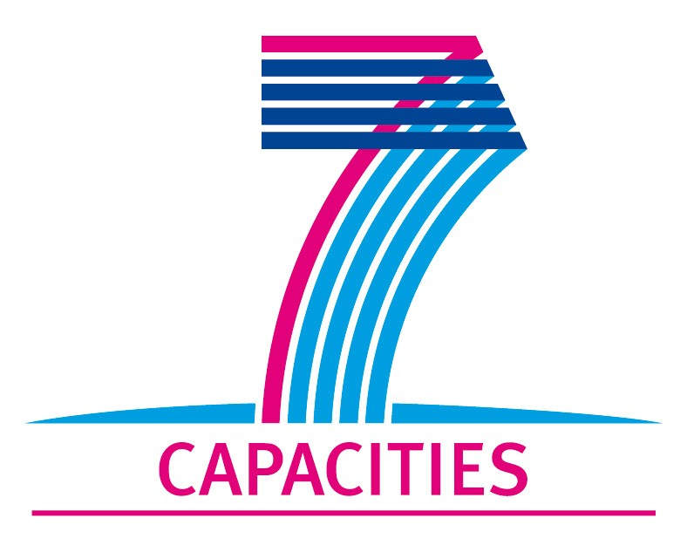

Application Form for MICROKELVIN Transnational Access Project

1. General Information

Project number: | AALTO16
Project Title: | Shot noise on suspended graphene at mK temperatures
Lead scientist: | Title: | Mr.
 | First name: | Daniel
 | Last name: | Cox
 | Birth date: | 21/01/1990
 | Passport number: | 461907995
 | Research status/Position: | Undergraduate (MPhys)
 | New User: | yes
 | Scientific Field: | Condensed matter (graphene)
 | Home institution: | University of Exeter
 | Is your home institution MICROKELVIN partner? | no
 | Business address: | Centre for Graphene Science, School of Physics, University of Exeter
 | Street: | Stocker Road
 | PO Box:
 | City: | Exeter
 | Zip/Postal Code: | EX4 4QL
 | Country: | UK
 | Telephone: | +44 (0)1392 264171
 | Fax: | +44 (0)1392 264111
 | E-mail: | dc287@ex.ac.uk
Curriculum vitae (18 lines max):
- Experience in creating, fabricating and measuring graphene devices in a clean environment, including exfoliation on different substrates (SiO2/PMMA) and different exfoliation methods, fabrication using both photolithography and electron beam lithography with thermal evaporation of contacts, low and high temperature measurements, and annealing of samples.
- Currently >80% grade in lab work
- Knowledge and some experience of characterising devices (and flakes) through transport measurements, Raman spectroscopy and other methods (Hall effect, etc.).
- Use of various computational tools to analyse results (typically Octave, Origin, AutoCAD).
 | Five most recent publications:
 | 1- Start of research career, no publications yet.
Other participating scientists: | Name:
 | 1 Saverio Russo (http://emps.exeter.ac.uk/staff/sr330)
2. Project Information

Name of host infrastructure: | LTL, Aalto University
Access provider / Infrastructure Director: | Name: Prof. Pertti Hakonen |  | E-mail address: pjh@neuro.hut.fi
Planned project dates: | Start date: | 01/07/2011 | Completion date: | 15/09/2011
Project description (12 lines max):
Graphene is a unique two-dimensional, gapless semiconductor: the conduction and valence bands touch in two inequivalent K points, the Dirac points where the density of states vanishes. However, the conductivity at the Dirac point remains finite. Indeed, it has been theoretically shown by M. Katsnelson and J. Tworzydlo et al. in 2006 that, in perfect graphene, the conduction occurs only via evanescent waves at the Dirac point. At LTL, investigations were performed in 2008 on electrical conductivity and shot noise in graphene strips, which supported these theoretical ideas, but the role of disorder in the studied graphene samples remained unclear. Since 2008, sample fabrication techniques have evolved substantially, and it has become time to redo those early measurements and to elucidate on the actual role of disorder. The number of impurities can drastically be reduced by making suspended graphene samples in which mean free paths up to one micron can be obtained in a straightforward manner. Such samples will provide a proper platform for testing theoretical models based on evanescent modes and beyond.
-
Scientific objectives of the project (12 lines max):
-
1. to investigate electrical transport in suspended graphene sheets,
2. to measure shot noise of ballistic graphene,
3. to verify basic models for electrical transport in graphene on the basis of shot noise and conductivity
(I: evanescent modes, II: weak electron-phonon coupling), and
4. to investigate coupling of mechanical motion to electrical transport.

Technical description of work to be performed (20 lines max):
1. preparation and characterisation of monolayer/few layer graphene samples,
2. releasing the graphene sheets using an appropriate method, for example HF-etching
3. characterization of the samples at DC at room temperature
4. selection of good samples for low temperature measurements
5. measurements in a dilution refrigerator with high frequency wiring and a cooled preamplifier
6. obtain data on high-frequency conductivity and shot noise of graphene sheets
7. analyze the data in terms of existing theories, especially paying attention to the role of evanescent
modes and the electron - optical phonon coupling.
8. in ballistic samples, investigate coupling between mechanical motion and electrical transport.

Of the above work list, items 1-4 will be performed in Exeter, while items 5-8 will be carried out as a Microkelvin project at LTL of Aalto University.

3. Joint Proposals / Funding

Is this project in collaboration with other (concurrent) projects at the infrastructure? No
If yes, please specify:

Is this proposal submitted to any funding programmes? No
If yes, please specify:

____________________
The completed Application Form should be submitted to MICROKELVIN Management Office (laitila@neuro.hut.fi, fax +358-9-47022969)

The lead scientist indicated here is expected to participate in the campaign as a user of the infrastructure.
Indicate ’Yes’ only if the user has never visited the infrastructure before this specific project, otherwise write ’No’.
Please list all participating user group members. Expand the table, if necessary.

