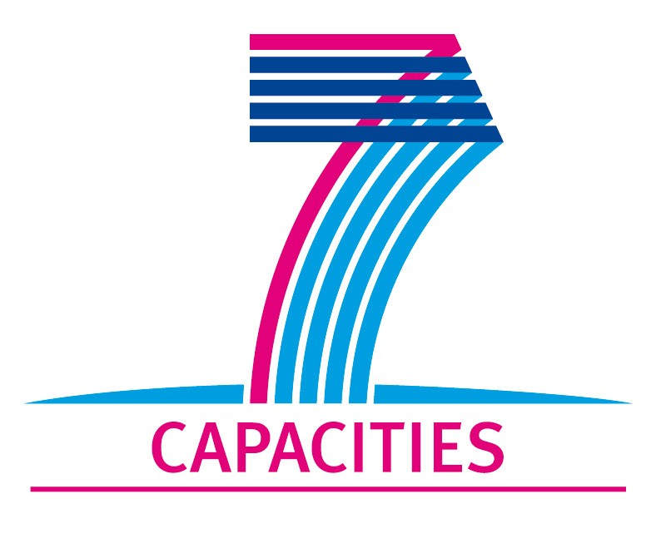

Application Form for MICROKELVIN Transnational Access Project

1. General Information

Project number: | AALTO 18
Project Title: | Andreev Scattering of Quasi-particles in Superfluid Helium 3-B
Lead scientist: | Title: | Professor
 | First name: | Carlo
 | Last name: | Barenghi
 | Home institution: | Newcastle University
Visiting scientist: | Title: | Doctor
 | First name: | Nugzar
 | Last name: | Suramlishvili
 | Birth date: | 23/09/66
 | Passport number: | 08AH90486
 | Research status/Position: | Research Associate
 | New User: | Yes
 | Scientific Field: | Superfluid ³He, Quantum Turbulence in ³He-B
 | Home institution: | Newcastle University
 | Is your home institution MICROKELVIN partner? | NO
 | Business address:
 | Street: | School of Mathematics and Statistics, Newcastle University, Herschel Building
 | PO Box:
 | City: | Newcastle upon tune
 | Zip/Postal Code: | NE1 7RU
 | Country: | United Kingdom
 | Telephone: | +44 (0)191 222 8327
 | Fax: | +44 (0)191 222 8020
 | E-mail: | n.suramlishvili@ncl.ac.uk
Curriculum vitae (18 lines max):
-EDUCATION:
-1983-1990 Department of Physics, Javakhishvili Tbilisi State University
1990-1993 Graduate School of Andronikashvili Institute of Physics, Tbilisi, Georgia.
1997 PhD Thesis (Solid states and Quantum liquids), Andronikashvili Institute of
Physics, Tbilisi, Georgia.
-LANGUAGES: Georgian, English, Russian
-GRANT PROJECTS:
4. Leverhulme Trust Grant F/00125/AH
3. EPSRC Grant, GR/T08876/01, 03/09/2007-29/02/2008
2. EPSRC Grant, GR/R54453/01, 01/08/2004-31/10/2006
1. Royal Society/NATO Post-doctoral Fellowship Grant, 15176/02B/TB,
01/05/2003-01/05/2004
-CONFERENCES:
3. 26th Int. Conf. on Low Temperature Physics (LT26), Beijing, 2011
2. Workshop on Topics in Quantum Turbulence, Trieste, Italy, 2009
1. 25th Int. Conf. on Low Temperature Physics (LT25), Amsterdam, 2008
-AWARDS RECEIVED: 1. Andronikashvili Prize of Georgian National Academy of Sciences, (2009). 2. The Georgian President's Stipend (2001)
 | Five most recent publications:
1-Y. A. Sergeev, C. F. Barenghi , N. Suramlishvili and P. J. van Dijk,
Two-dimensional model of interactions between thermal quasiparticles and turbulent
structures in ³He-B, EPL, 90, , 56003 (2010).
 | 2-Y.A. Sergeev, C.F. Barenghi, and N. Suramlishvili, ”Visualization of quantum turbulence in ³He-B by thermal excitations”, in Advances in Turbulence XII, Springer Proceedings in Physics, Vol. 132, Springer-Verlag, Berlin-Heidelberg, 285-288
 | 3-C.F. Barenghi, Y.A. Sergeev, N. Suramlishvili, and P.J. van Dijk, ”Interaction of ballistic quasiparticles and vortex configurations in superfluid ³He-B, Phys. Rev. B., 79, 024508 (2009).
 | 4-C.F. Barenghi, Y.A. Sergeev and N. Suramlishvili, ”Ballistic propagation of thermal excitations near a vortex in superfluid ³He-B”. Phys. Rev. B, 77, 104512 (2008).
5-S.N.Fisher and N.Suramlishvili. ”Coherently precessing spin and orbital states in superfluid ³He-B”.
Journal of Low Temperature Physics, 141, No 3/4, p.111-141 (2005).
Other participating scientists: | Name: Yuri Sergeev |  | Position: Professor | New User: Yes
2. Project Information

Name of host infrastructure: | Low Temperature Laboratory, Aalto University
Access provider / Infrastructure Director: | Name:  Professor Nikolai Kopnin |  | E-mail address:  kopnin@boojum.hut.fi
Planned project dates: | Start date: | [17/10/2011] | Completion date: | [26/10/2011]
Project description (12 lines max):
Our current project, funded by the Leverhulme Trust, is concerned with a method, based on the Andreev reflection technique of detection of quantized vortices in superfluid ³He-B. Until now, Andreev reflection has been used only to determine the average intensity (vortex line density) in turbulent superfluids. We developed the numerical code which enables us to simulate vortex configurations and fully developed vortex tangles solving simultaneously the equations of motion of thermal quasiparticle excitations. Our aim is to determine whether the Andreev reflection technique can provide the information more detailed than just the vortex line density. Apart from studying the thermal transparency of rectilinear structures, a gas of vortex ring, and the dense tangle, we explore the idea that Kelvin waves can be detected by measuring the fluctuations of the intensity of Andreev reflected quasiparticles.
Scientific objectives of the project (12 lines max):
Further progress of our project requires the development of numerical models based on deeper understanding of interactions between quasiparticles and quantized vortices in ³He-B. During his visit, Dr Suramlishvili’s first objective will be to discuss with Professor Nikolai Kopnin and his colleagues within the Helium Theory Group the problem of influence of vortex core states on the outcome of reflected quasiparticles. It is hoped that incorporating the core structure and bound states into our numerical model will make it more realistic. The second objective is to apply our numerical method to the particular geometry corresponding to recent experiments, performed by Prof. Matti Krusius and his colleagues within the Rota Group, where the vortex structure is created by rotating the ³He-B sample at constant angular velocity and the line density, orientation and spatial extent of the vortices are well defined. This may help to interpret the existing experimental data and to create a better link between the theory and future experiments. It is also hoped that these discussions will lead to collaborative research between Newcastle and Aalto Universities.
Technical description of work to be performed (20 lines max):
The Andreev reflection technique is based on the fact that the dispersion curve E (p) of quasiparticles is tied to the reference frame of the superfluid, so, in a superfluid moving with velocity v_{S} , the dispersion curve becomes E (p ) + p · v_{S} , where p is the momentum. E (p) plays the role of a Hamiltonian. The semi-classical Hamilton's equations describing the propagation of ballistic thermal excitations in the velocity field of three dimensional structure of quantized vortices are solved by a code, which is variable step, variable order implementation in Fortran programming language of the Numerical Differentiation Formulas particularly efficient for solving stiff problems. The superfluid velocity is given by the Biot-Savart Law and is calculated by means of the vortex filament method using periodic boundary conditions.
The purpose of Dr Suramlishvili’s visit to Aalto University is two-fold:
- To seek expert advice from Dr. Nikolai Kopnin and his colleagues on further development of our numerical model in order to incorporate the core structures and quasiparticle bound states;
- To establish closer collaboration with experimentalists, in particular with Prof. Matti Krusius and his colleagues, in order to apply our numerical model to recent and future experiments performed within the Low Temperature Laboratory.

3. Joint Proposals / Funding

Is this project in collaboration with other (concurrent) projects at the infrastructure? No
If yes, please specify:

Is this proposal submitted to any funding programmes? No
If yes, please specify:

____________________
The completed Application Form should be submitted to MICROKELVIN Management Office (Katariina.Toivonen@neuro.hut.fi, fax +358-9-47022969)

The lead scientist indicated here is expected to participate in the campaign as a user of the infrastructure.
Indicate ’Yes’ only if the user has never visited the infrastructure before this specific project, otherwise write ’No’.
Please list all participating user group members. Expand the table, if necessary.

