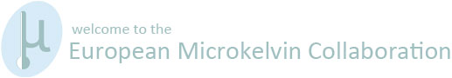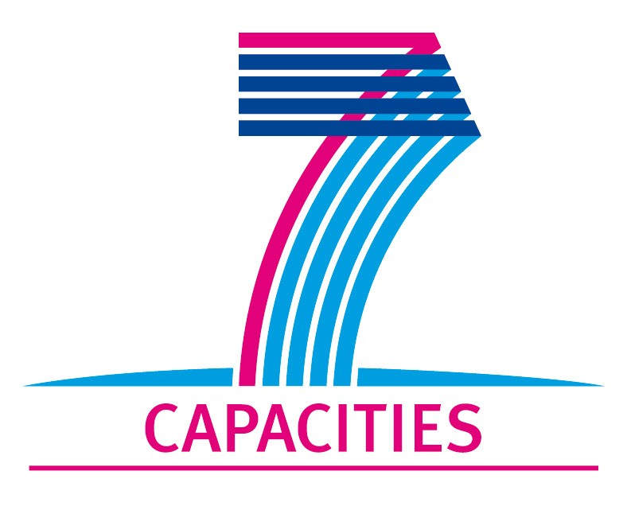

Application Form for MICROKELVIN Transnational Access Project

1. General Information

Project number: | AALTO 19
Project Title: | Vortex waves in rotating superfluid 3He-B
Host scientist: | Title: | Dr.
 | First name: | Vladimir
 | Last name: | Eltsov
 | Home institution: | Aalto University, Finland
Visiting scientist: | Title: | Dr.
 | First name: | Paul
 | Last name: | Walmsley
 | Birth date: | 16th June 1977
 | Passport number: | 210321791
 | Research status/Position: | Research Fellow
 | New User: | No
 | Scientific Field: | Superfluid hydrodynamics and turbulence
 | Home institution: | University of Manchester, UK
 | Is your home institution MICROKELVIN partner? | No
 | Business address: | Condensed Matter Physics Group  School of Physics and Astronomy  University of Manchester
 | Street: | Oxford Road
 | PO Box:
 | City: | Manchester
 | Zip/Postal Code: | M13 9PL
 | Country: | United Kingdom
 | Telephone: | +44-161-2754248
 | Fax:
 | E-mail: | Paul.Walmsley@manchester.ac.uk
Curriculum vitae (18 lines max):

2010 – Present: Research Fellow, University of Manchester.
2003 – 2010 : Research Associate, University of Manchester.
2003 : Ph.D., University of Manchester, ‘Textures, vortices and persistent currents in a slab of superfluid ³He-A.’
1999 : Mphys(Hons.) Physics (First class), University of Manchester.

Research Expertise:
- Superfluid turbulence in the zero temperature limit.
- Textures and topological defects in superfluid ³He-A.
- Rotating dilution refrigerators.
 | Five most recent publications:
 | 1- P.M. Walmsley, V.B. Eltsov, P.J. Heikkinen, J.J. Hosio, R. Hänninen, and M. Krusius, Turbulent vortex flow responses at the AB interface in rotating superfluid 3He-B, arXiv:1108.4283.
 | 2- A.I. Golov, P.M. Walmsley and P.A. Tompsett, Charged Tangles of Quantized Vortices in Superfluid ⁴He, J. Low Temp. Phys. 161, 509 (2010).
 | 3- A.I. Golov and P.M. Walmsley, Homogeneous turbulence in superfluid ⁴He in the low temperature limit: experimental progress, J. Low Temp. Phys. 156, 51 (2009).
4- P.M. Walmsley, A.I. Golov, H.E. Hall, W.F. Vinen, and A.A. Levchenko,
Decay of turbulence generated by spin-down to rest in superfluid 4He, J. Low Temp. Phys. 153, 127 (2008).
 | 5- V.B. Eltsov, R. de Graaf, R. Hanninen, M. Krusius, R.E. Solntsev, V.S. L’vov, A.I. Golov and P.M. Walmsley, Turbulent dynamics in rotating helium superfluids, chapter 2 in: Progress in Low Temperature Physics (vol. 16): Quantum Turbulence, ed. by M. Tsubota (Elsevier Science, 2008).
Other participating scientists: | Name: |  | Position: | New User:2
 | 1-
 | 2-
 | 3-
2. Project Information

Name of host infrastructure: | Low Temperature Laboratory, Aalto University
Access provider / Infrastructure Director: | Name: Pertti Hakonen |  | E-mail address: pjh@boojum.hut.fi
Planned project dates: | Start date: | [09/01/2012] | Completion date: | [18/02/2012]
Project description (12 lines max):
Kelvin waves on vortex lines are believed to be an important component of quantum turbulence in superfluids at low temperatures. In particular, energy transfer over the Kelvin-wave cascade is responsible for a finite rate of the energy dissipation in the zero-temperature limit. Up to date, however, Kelvin waves in superfluids and the Kelvin-wave cascade have not been probed experimentally. We plan to study a type vortex motion, which is closely related to Kelvin waves on individual vortex lines: vortex waves on the arrays of vortices. We intend to produce such vortex arrays by rotation of a long cylindrical 3He-B sample at temperatures below 0.3Tc down to 0.15Tc. Vortices will be pinned at one end of the cylinder at a rough surface. The angular velocity of rotation will be modulated to create vortex waves. Their build-up, propagation and relaxation will be monitored using two nuclear magnetic resonance spectrometers at different heights in the cylinder and by Andreev scattering from vortex lines using quartz tuning forks.
Scientific objectives of the project (12 lines max):
The eventual goal is to learn about the role of vortex waves in superfluid dissipation processes in the zero-temperature limit. The immediate goal is to understand the effect of the oscillations in a vortex cluster on the frequency shift of the magnon condensate NMR mode, which was observed in preliminary measurements [J. Low Temp. Phys. 162, 212 (2011)]. The current hypothesis is that the effect is due to the reduction in the polarization of vortices in the cluster when vortex waves are created. However, this is still to be proven by performing more detailed measurements and comparing to numerical simulations. Alternative explanations may include the twisting oscillations of non-axisymmetric vortex cores, which would also be an interesting development. An additional goal is to find out whether oscillating objects within the vortex cluster can be used as sensitive probes of vortex waves due to the screening of thermal quasiparticles, similar to the techniques developed in Lancaster for studying quantum turbulence.
Technical description of work to be performed (20 lines max):
The 3He-B sample inside a quartz cylinder of 150mm length and 6mm diameter will be cooled down to 0.15Tc using a rotating nuclear demagnetization cryostat. Rotation at 0.1 - 3 rad/s will be applied and the equilibrium vortex cluster will be created. At one end of the cylinder the cluster will terminate at a rough sinter surface, which provides vortex pinning. The order-parameter texture of 3He-B, which depends on the vortex configuration, will be probed using two NMR spectrometers. In particular, the frequency shift of the magnon condensate mode in the textural potential well will be a most sensitive probe. We then apply modulation to the rotation velocity at different frequencies and amplitudes and record how the frequency shift of the magnon condensate changes with time when the modulation is switched on/off. To aid the interpretation of the measurements we will adapt an existing computer program for the numerical calculation of the order-parameter texture to vortex configurations with waves. Additionally, the dissipation of a quartz tuning fork oscillator, located within the vortex array, will be recorded as a function of time. For the interpretation of the fork measurements a second computer program will be adapted to the calculation of vortex configurations with waves, to trace quasiparticle motions by means of Andreev reflection from vortex lines. We will compare these results to direct numerical vortex filament calculations of vortex dynamics, to be performed outside this project by Dr. Risto Hänninen.

3. Joint Proposals / Funding

Is this project in collaboration with other (concurrent) projects at the infrastructure? Yes
If yes, please specify: Numerical calculations of vortex dynamics by Risto Hänninen

Is this proposal submitted to any funding programmes? No
If yes, please specify:

____________________
The completed Application Form should be submitted to MICROKELVIN Management Office (Katariina.Toivonen@neuro.hut.fi, fax +358-9-47022969)

The lead scientist indicated here is expected to participate in the campaign as a user of the infrastructure.
Indicate ’Yes’ only if the user has never visited the infrastructure before this specific project, otherwise write ’No’.
Please list all participating user group members. Expand the table, if necessary.

