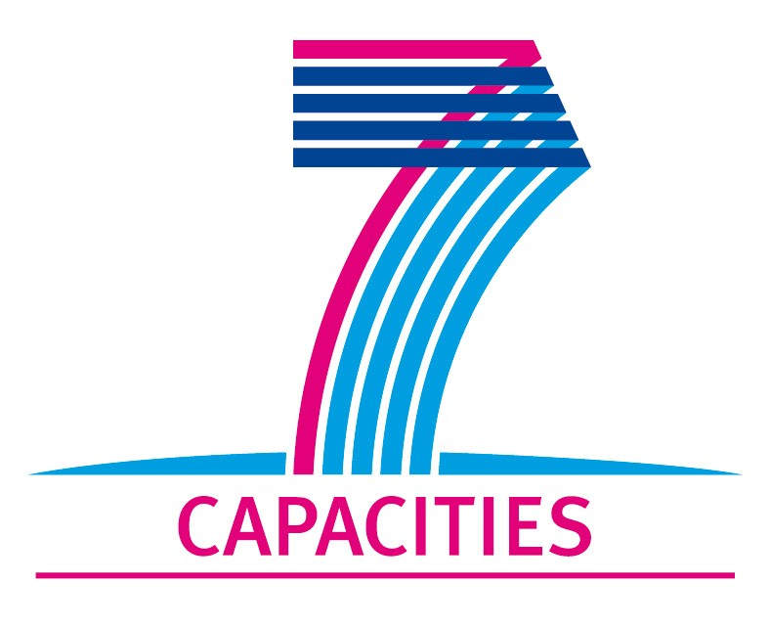
Application Form for MICROKELVIN Transnational Access Project

1. General Information
Project number: | CNRS07
Project Title: | Late-time dynamics of quantized vortices generated after absorption of a neutron in superfluid 3He-B
Lead scientist: | First name: | Andrey
Lead scientist: | Last name: | Golov
Lead scientist: | Birth date:
Lead scientist: | Research status/Position: | Prof.
Lead scientist: | New User: | No
Lead scientist: | Scientific Field: | Experimental investigations of vortex dynamics in helium superfluids
Lead scientist: | Home institution: | Schuster Laboratory, University of Manchester
Lead scientist: | Home institution is MICROKELVIN partner: | No
Lead scientist: | Business address: | Schuster Laboratory, University of Manchester
Lead scientist: | Street: | Oxford Road
Lead scientist: | Street No.:
Lead scientist: | PO Box:
Lead scientist: | City: | Manchester
Lead scientist: | Zip/Postal Code: | M13 9PL
Lead scientist: | Country: | UK
Lead scientist: | Telephone: | +44-161-2754068
Lead scientist: | Fax: | +44-161-2754056
Lead scientist: | E-mail: | andrei.golov@manchester.ac.uk
Lead scientist: | Curriculum vitae (18 lines max):  Education:  Kolmogorov Special Boarding School for Physics and Mathematics at MSU, 1975–77;  Moscow Institute of Physics and Technology, 1977–1983;  PhD: Motion of ions in solid helium, Inst. of Solid State Physics, Chernogolovka, 1989.  Appointments held:  Professor of Condensed Matter Physics, University of Manchester, 2009 – present;  Reader in Low Temperature Physics, University of Manchester, 2005–2009;  Senior Lecturer in Low Temperature Physics, University of Manchester, 2004–2005;  Lecturer in Low Temperature Physics, University of Manchester, 1998–2004;  Research Associate, LASSP, Cornell University, USA, 1996–1998;  Research Associate, Institute of Solid State Physics, Russian Acad. of Sci., 1989–1996.  Visiting appointments/secondments:  Alexander von Humboldt Fellow, Bayreuth University, Germany, 1992–1994;  Visiting Professor/Research Fellow, ISSP, University of Tokyo, Japan, 1995–1996;  Visiting Fellow, Helsinki University of Technology, Finland, 2006–2007;  Invited Professor, Joseph Fourier University, Grenoble, France, 2009.
Lead scientist: | Five most recent publications (on helium superfluids):
Lead scientist: | P.M. Walmsley and A.I. Golov, Quantum and quasiclassical types of superfluid turbulence, Phys. Rev. Lett. 100, 245301 (2008).
Lead scientist: | V.B. Eltsov, R. de Graaf, R. Hanninen, M. Krusius, R.E. Solntsev, V.S. L'vov, A.I. Golov, and P.M. Walmsley, Turbulent dynamics in rotating helium superfluids, Progress in Low Temperature Physics, XVI pp. 46-146 (2009), DOI:0.1016/S0079-6417(08)00002-4 ; arXiv:0803.3225
Lead scientist: | P.M.Walmsley, A.I.Golov, H.E.Hall, W.F.Vinen, A.A.Levchenko, Decay of turbulence generated by spin-down to rest in superfluid ⁴He, J. Low Temp.  Phys. 153, 127-139 (2009).
Lead scientist: | A.I.Golov, P.M.Walmsley, Homogeneous Turbulence in Superfluid ⁴He in the Low-Temperature Limit: Experimental Progress. J. Low Temp. Phys. 156, 51-70 (2009).
Lead scientist: | A.I.Golov, P.M.Walmsley, P. Tompsett. Charged Tangles of Quantized Vortices in Superfluid ⁴He, J. Low Temp. Phys. 161, 509-525 (2010).
Other participating scientists: | Name: |  | Position: | New User:²
Other participating scientists: | 1 – Viktor L’vov |  | Professor, Weizmann Institute of Science, Rehovot, Israel | no

2. Project Information

Name of host infrastructure: | MCBT, Institut Neel, Grenoble, France
Access provider / Infrastructure Director: | Name: Prof. Yury Bunkov |  | E-mail address: yuriy.bunkov@grenoble.cnrs.fr
Access provider / Infrastructure Director: | Prof. Henry Godfrin |  | henri.godfrin@grenoble.cnrs.fr
Planned project dates: | Start date: | 16/7/2011 | Completion date: | 26/7/2011
Project description (12 lines max):
The objective is to improve our understanding of the processes occurring after rapid quench-cooling of a small heated bubble of liquid 3He within a bulk superfluid bath at very low temperatures. We propose to conduct a thorough analysis of experimental results on the number of metastable topological defects left in superfluid 3He-B after the absorption of one neutron and to elaborate a new ``inflationary'' model that will account for the initial spreading and growth of the vortex tangle (and also extraction of long-lived individual vortex rings/loops) under the outward wind of thermal excitations immediately following the ``mini Big Bang''. Comparison of the specific predictions of this modified model with various existing experimental observations should hopefully help to improve the quantitative interpretation of experiments with respect to the efficiency of the Kibble-Zurek mechanism for the generation of topological defects.

Scientific objectives of the project (12 lines max):
At present there are major unresolved questions concerning the correct interpretation of the different dynamic measurements at the lowest temperatures. Clearly the dynamics should be understood better if we ever want to make use of the helium superfluids as laboratory model systems of coherent quantum matter in the vacuum T → 0 limit.
Prof. Golov has studied extensively in laboratory measurements the free decay of homogeneous and isotropic superfluid turbulence in superfluid 4He with ion transmission techniques. Current understanding of the decay is formulated in terms of the Richardson – Kolmogorov hydrodynamic energy cascade which ultimately at sufficiently low mutual friction dissipation and small length scales (comparable to the inter-vortex distance) couples to Kelvin waves propagating on single vortex lines. It is important to understand how these theories apply to the propagating temperature front in the context of the Kibble-Zurek phenomenon. The new experimental data is expected to provide a better understanding about the consistency between measurement and calculation and hopefully ultimately about the mechanisms which control defect formation in the Kibble-Zurek process.
Technical description of work to be performed (20 lines max):
A thorough analysis of the experimental data from the DN1 cryostat of the Microkelvin facility has been performed. The applicability of the "standard" Kibble-Zurek model of the nucleation of topological defects in homogeneous conditions was reviewed. Various assumptions of the model have been critically checked. As a result, several new mechanisms leading to vortex production, multiplication and conservation were suggested and discussed. Preliminary estimates of the rates and efficiencies of the different mechanisms have been made that will provide a basis for further analytical and numerical modeling.

3. Joint Proposals / Funding

Is this project in collaboration with other (concurrent) projects at the infrastructure? Yes
Specify: Quantum turbulence in the zero temperature limit

Is this proposal submitted to any funding programmes? No
If yes, please specify: None

____________________
The completed application form should be submitted to the MICROKELVIN Management Office

The lead scientist indicated here is expected to participate in the campaign as a user of the infrastructure.
Indicate ’Yes’ only if the user has never visited the infrastructure before this specific project, otherwise write ’No’.
Please list all participating user group members. Expand the table, if necessary.

