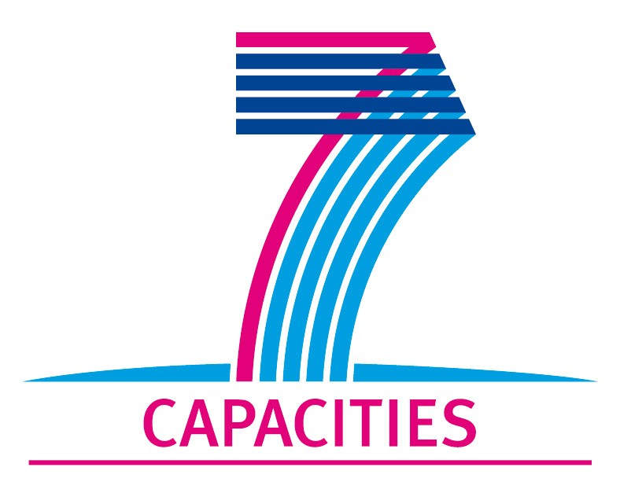
Application Form for MICROKELVIN Transnational Access Project

1. General Information
Project number: | CNRS07
Project title: | Late-time dynamics of quantized vortices generated after absorption of a neutron in superfluid 3He-B
Lead scientist: | First name: | Victor
Lead scientist: | Last name: | L’vov
Lead scientist: | Birth date:
Lead scientist: | Research status/Position: | Prof.
Lead scientist: | New User: | No
Lead scientist: | Scientific Field: | Quantum turbulence in helium superfluids
Lead scientist: | Home institution: | Weizmann Institute of Science, Rehovot, Israel
Lead scientist: | Home institution is MICROKELVIN partner: | No
Lead scientist: | Business address: | Weizmann Institute of Science
Lead scientist: | Street:
Lead scientist: | Street No.:
Lead scientist: | PO Box:
Lead scientist: | City: | Rehovot
Lead scientist: | Zip/Postal Code: | 76100
Lead scientist: | Country: | Israel
Lead scientist: | Telephone: | +972(8)9343750
Lead scientist: | Fax: | +972(8)9344123
Lead scientist: | E-mail: | Victor.Lvov@gmail.com  http://lvov.weizmann.ac.il
Lead scientist: | Curriculum vitae (18 lines max):  Prof. L’vov is a senior member of the permanent staff at the Weizmann Institute and a widely known expert of hydrodynamic theory in both viscous and superfluid flow. He comes from the Institute of Automatization in Novosibirsk (Russian Academy of Sciences) from where he moved to the Weizmann Institute in the early nineties.
Lead scientist: | Five most recent publications (on helium superfluids):
Lead scientist: | V.S. L'vov, S.V. Nazarenko, and O. Rudenko, Bottleneck crossover between classical and quantum superfluid turbulence, Phys. Rev. B 76, 024520 (2007). DOI: 10.1103/PhysRevB.76.024520
Lead scientist: | V. S. L'vov, S. V. Nazarenko, and O. Rudenko, Gradual eddy-wave crossover in superfluid turbulence, J. of Low Temp. Phys. 153, 140-161 (2008). DOI:s10909-008-9844-0
Lead scientist: | V.S. L’vov, Anna Pomyalov, I. Procaccia, and O. Rudenko, Finite-dimensional turbulence of planetary waves, Phys. Rev. E 80, 066319 (2009) – Published December 30, 2009.
Lead scientist: | V.B. Eltsov, R. de Graaf, R. Hanninen, M. Krusius, R.E. Solntsev, V.S. L'vov, A.I. Golov, and P.M. Walmsley,Turbulent dynamics in rotating helium superfluids, Progress in Low Temperature Physics, XVI pp. 46-146 (2009), DOI:0.1016/S0079-6417(08)00002-4 ; arXiv:0803.3225
Lead scientist: | J. Laurie, V.S. L’vov, S. Nazarenko, and O. Rudenko, Interaction of Kelvin waves and nonlocality of energy transfer in superfluids, Phys. Rev. B 81, 104526 (2010) – Published March 26, 2010.
Lead scientist: | V. S. L’vov and S. Nazarenko, Discrete and mesoscopic regimes of finite-size wave turbulence, Phys. Rev. E 82, 056322 (2010) – Published November 19, 2010.
Lead scientist: | V.S. L’vov and S.V. Nazarenko, Spectrum of Kelvin-wave turbulence in superfluids, Pis’ma v ZhETF 91, 464 (2010) ; arXiv :0911.2065v5
Lead scientist: | V. L’vov and S. Nazarenko, Comment on “Superfluid Turbulence from Quantum Kelvin Wave to Classical Kolmogorov Cascades” , Phys. Rev. Lett. 104, 219401 (2010) – Published May 25, 2010.
Lead scientist: | V. B. Eltsov, R. de Graaf, P. J. Heikkinen, J. J. Hosio, R. Hänninen, M. Krusius, and V. S. L’vov, Stability and Dissipation of Laminar Vortex Flow in Superfluid ³He-B , Phys. Rev. Lett. 105, 125301 (2010) – Published September 14, 2010.
Other participating scientists: | Name: |  | Position: | New User:²
Other participating scientists: | 1 – Andrey Golov |  | professor  Manchester University, UK | no

2. Project Information

Name of host infrastructure: | MCBT, Institut Neel, Grenoble, France
Access provider / Infrastructure Director: | Name: Prof. Yury Bunkov |  | E-mail address: yuriy.bunkov@grenoble.cnrs.fr
Access provider / Infrastructure Director: | Prof. Henry Godfrin |  | henri.godfrin@grenoble.cnrs.fr
Planned project dates: | Start date: | 16/7/2011 | Completion date: | 26/7/2011
Project description (12 lines max):
The objective is to improve our understanding of the processes occurring after rapid quench-cooling of a small heated bubble of liquid 3He within a bulk superfluid bath at very low temperatures. We propose to conduct a thorough analysis of experimental results on the number of metastable topological defects left in superfluid 3He-B after the absorption of one neutron and to elaborate a new ``inflationary'' model that will account for the initial spreading and growth of the vortex tangle (and also extraction of long-lived individual vortex rings/loops) under the outward wind of thermal excitations immediately following the ``mini Big Bang''. Comparison of the specific predictions of this modified model with various existing experimental observations should hopefully help to improve the quantitative interpretation of experiments with respect to the efficiency of the Kibble-Zurek mechanism for the generation of topological defects.

Scientific objectives of the project (12 lines max):
At present there are major unresolved questions concerning the correct interpretation of the different dynamic measurements at the lowest temperatures. Clearly the dynamics should be understood better if we ever want to make use of the helium superfluids as laboratory model systems of coherent quantum matter in the vacuum T → 0 limit.
Prof. L’vov has studied extensively the decay of homogeneous and isotropic superfluid turbulence via the Richardson – Kolmogorov hydrodynamic energy cascade which ultimately at sufficiently low mutual friction dissipation and small length scales (comparable to the inter-vortex distance) couples to Kelvin waves propagating on single vortex lines. It is important to understand to how these theories apply to the propagating temperature front. The new experimental data is expected to provide a better understanding about the consistency between measurement and calculation and hopefully ultimately about the mechanisms which control defect formation in the Kibble-Zurek process.
Technical description of work to be performed (20 lines max):
A thorough analysis of the experimental data from the DN1 cryostat of the Microkelvin facility has been performed. The applicability of the "standard" Kibble-Zurek model of the nucleation of topological defects in homogeneous conditions was reviewed. Various assumptions of the model have been critically checked. As a result, several new mechanisms leading to vortex production, multiplication and conservation were suggested and discussed. Preliminary estimates of the rates and efficiencies of the different mechanisms have been made that will provide a basis for further analytical and numerical modeling.

3. Joint Proposals / Funding

Is this project in collaboration with other (concurrent) projects at the infrastructure? Yes
Specify: Quantum turbulence in the zero temperature limit

Is this proposal submitted to any funding programmes? No
If yes, please specify: None

____________________
The completed application form should be submitted to the MICROKELVIN Management Office

The lead scientist indicated here is expected to participate in the campaign as a user of the infrastructure.
Indicate ’Yes’ only if the user has never visited the infrastructure before this specific project, otherwise write ’No’.
Please list all participating user group members. Expand the table, if necessary.

