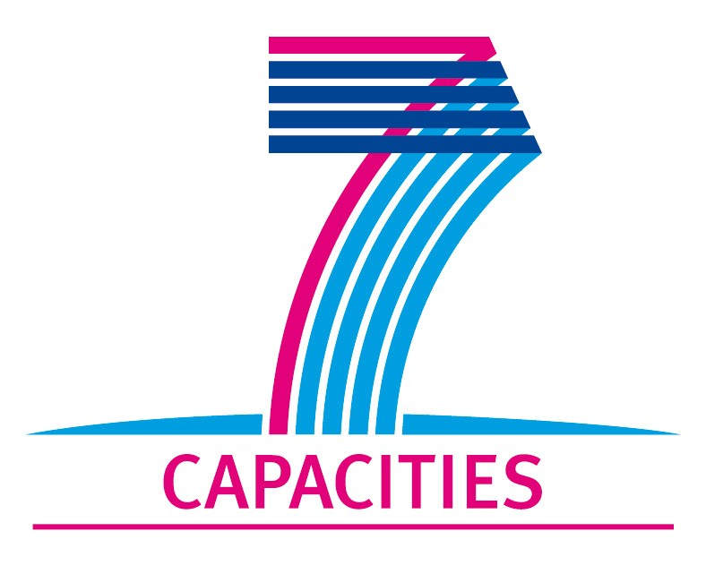

MICROKELVIN Transnational Access Project Report

1. General information

Project number: | Lancaster 01
Project Title: | Quantum turbulence generated and detected using a floppy wire
Lead scientist: | Title: | Dr.
 | First name: | Marcel
 | Last name: | Clovecko
 | Birth date: | 9/12/1981
 | Passport number: | SL 507115
 | Research status/Position: | Researcher
 | New User: | YES
 | Scientific Field: | Quantum fluids, quantum turbulence
 | Home institution: | Department of Low Temperature Physics, Institute of Experimental Physics, Slovak Academy of Sciences, Watsonova 47, 040 01 Košice
 | Is your home institution MICROKELVIN partner? | YES
 | Business address:
 | Street: | Watsonova 47
 | PO Box:
 | City: | Košice
 | Zip/Postal Code: | 040 01
 | Country: | Slovakia
 | Telephone: | +421 55 622 8158
 | Fax: | +421 55 622 8158
 | E-mail: | clovecko@saske.sk

2. Project information

Please, give a brief description of project objectives:  (250 words max) | Quantum turbulence has recieved a great deal on interest in recent years. The traditional technique to create quantum turbulence in non-rotating cryostats is by means of mechanical resonators (vibrating wires and etc.). These resonators typically have very small displacements and produce localised vortex tangles. The resulting inhomogeneity may affect the dynamics of the tangle. This project will develop a new technique to produce much more homogeneous quantum turbulence. A large `floppy‘ wire will be used to draw a grid through an enclosed region to generate homogeneous turbulence.  The main objective of the project is to develop the new technique of operating a `floppy’ wire to make a single large-amplitude sweep through a superfluid. When attached to a grid, this will allow us to generate homogeneous turbulence. It will also be interesting to study the response of the wire itself, particularly in 3He-B at ULT. A resonator in 3He-B is known to break Cooper pairs above a velocity of one third of the Landau velocity, VL/3, and turbulence is generated simultaneously. Pair-breaking below VL is possible due to the transient filling of surface bound states around the wire. The vortex production may be quite different for quasi-static flow.  This visit was used to design and manufacture the device, to develop the measurement techniques and associated electronics, and to make some preliminary tests in normal and superfluid 4He. Following this, a device will be installed in a Lancaster style nuclear cooling stage to perform experiments in 3He-B at ultralow temperatures.
Technical description of work performed:  (250 words max) | A goal-post shaped `floppy’ wire was constructed from 0.1 mm single-core superconducting wire. Two different types of floppy wires were manufactured – with and without a grid mesh. Each wire was 25 mm tall and 9 mm wide. The copper cladding was left intact, since we found that its removal tends to distort the shape of the wire loop.  The device was driven at low temperatures by passing a current through it, using a custom built current source, in a perpendicular magnetic field. A dc current produces a static deflection, and a step change in the current produces a transient motion to the new equilibrium position. A relatively large loop of fine wire allows us to produce relatively large deflections of the order of a several mm.  To detect the position of the loop a small ac current, from a high quality function generator, is superimposed on the dc current. This induces Faraday voltages, measured by DSP lockin amplifiers, in two near-by detection coils. We found that a relatively high frequency produces the best signal-to-noise ratio, so we used 96 kHz for the majority of measurements (limited by the measurement electronics). The position of the device is calibrated by measuring the signals from the detection coils (which have a known spacing) as a function of the dc current. The measurements are coordinated and controlled by computer with labveiw software and a DAC card.  We made new devices and developed the measurement techniques with preliminary measurements in normal and superfluid 4He.
Project achievements (and difficulties encountered):⁵  (250 words max) | We successfully made new devices and installed and tested them in liquid Helium. A wire with an attached grid was measured in normal and superfluid 4He. The measurements were compared with the wire’s ac response which we measured in the same way as a conventional vibrating wire resonator (its resonant frequency was about 50Hz). The wire position was successfully calibrated from the induced voltage as a function of DC current. To a good approximation, the deflection is directly proportional to the DC current so it is relatively simply to calibrate. We demonstrated that the technique provides a very accurate measurement of the position of loop with good time resolution.  Rather than stepping the DC current, we found that linear ramps worked much better, we allowed us to control the transient velocities over a wide range. Typical ramp times were in the range 10 to 100 ms. We were able to determine the instantaneous velocity of the loop as a function of the instantaneous driving force. The wire has a relatively high Q factor so damped oscillations were readily seen. We compared the behaviour with calculation based on a linear harmonic oscillator. More measurements have to be done to fully understand this behaviour.  A floppy wire will be installed in a new cell for experiments in superfluid 3He. Our results were very useful in developing the design and measurement techniques. The device itself is quite versatile and may find many applications to other areas of quantum fluids and solids research.
Expected publications and dates: | - Preliminary measurements and results will be presented at Cryoconference 2010 which will take place 9-15 September 2010 in Mýto pod Ďumbierom, Low Tatras, Slovakia  - After a few further measurements we hope to publish preliminary results in the next few months.
Submission date of user group questionnaire:

Completed Project Reports should be returned to MICROKELVIN Management Office (Katariina.Toivonen@neuro.hut.fi, Fax: +358 9 47022969).

The lead scientist indicated here is expected to participate in the campaign as a user of the infrastructure.
Indicate ’Yes’ only if the user has never visited the infrastructure before this specific project, otherwise write ’No’.

