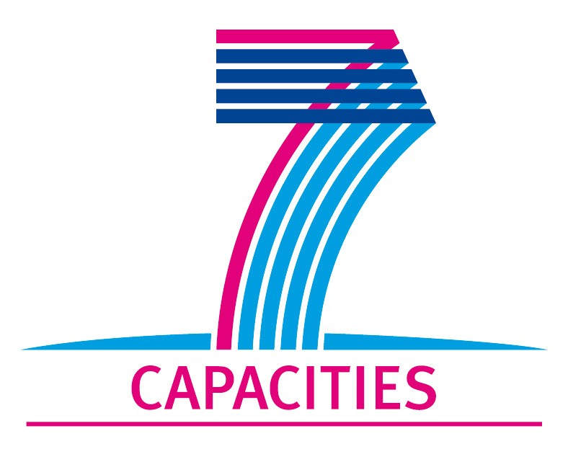

MICROKELVIN Transnational Access Project Report

1. General information

Project number: Lancaster 02
Project Title: | Novel type of heat exchangers for nuclear cooling refrigerators
Lead scientist:1 | Title: |  | RNDr., PhD.
First name: |  | Slavomír
Last name: |  | Gabáni
Birth date: |  | 18th April 1974
Passport number: |  | 4912551
Research status/Position: |  | Physicist/senior research fellow
New User:2 |  | Yes
Scientific Field:
Home institution: |  | Institute of Experimental Physics, SAS
Is your home institution MICROKELVIN partner? |  | Yes
Business address:
Street: |  | Watsonova 47
PO Box:
City: |  | Košice
Zip/Postal Code: |  | 04001
Country: |  | Slovakia
Telephone: |  | 00421 55 6228158
Fax: |  | 00421 55 6336292
E-mail: |  | gabani@saske.sk

2. Project information

Please, give a brief description of project objectives:  (250 words max) | The primary scientific and technological objectives of the proposed project are to use the facilities and skills base at Lancaster to further develop our own skills and specialist techniques to design and manufacture high performance heat exchangers. We will use these skills, and the specialist facilities at Lancaster, to commence building a new set of high performance heat exchangers for our own dilution refrigerator at Kosice which will vastly improve our low temperature capabilities. We will also use the Lancaster facilities to develop our techniques for maximising the efficiency and performance of dilution refrigerators, for measuring and monitoring the temperature of the refrigerator, and for running demagnetisation experiments to cool samples to micro-Kelvin temperatures.
Technical description of work performed:  (250 words max) | During the visit we have learnt a lot of new skills and techniques from our colleagues in the Lancaster ULT group. We have learned how to optimise the design and calculate the best geometrical parameters of the silver sinter used for discrete (step) heat exchangers. The Lancaster group’s technicians demonstrated all of the technical procedures which they use to make and install step heat exchangers. Under their guidance we have designed and manufactured a step heat exchanger ourselves, using their techniques. Under their continued guidance, we have performed a leak test of the step exchanger at room temperature and have been instructed on how best to perform tests at lower temperatures. We have also developed other cryogenic and technical skills whilst helping them to construct some elements of their new advanced mickrokelvin facility. In particular we have participated in soldering and leak tests of the 4K vacuum flange at room and liquid nitrogen temperatures, and we have helped to install the aluminium room temperature flange (top plate) for the new machine. We have also observed and discussed various cooling and running techniques employed by the Lancaster ULT group to operate their other refrigerators.
Project achievements (and difficulties encountered):⁵  (250 words max) | The major achievement of this project was the highly successful transfer of techniques and knowledge concerning the design and manufacture of state-of-the-art discrete (step) heat exchangers between the laboratories in Lancaster and Kosice. We will directly apply this newly acquired knowledge and skills in the design and fabrication of a new, much improved, set of discrete heat exchangers for our dilution refrigerator. The knowledge and skills will also be very valuable for constructing new experimental cells and cooling stages used for superfluid 3He research at Kosice. We have also learnt valuable new techniques and methods for building new advanced cooling machines and we have gained experience of their advanced techniques used for vibration isolation. In addition we have learnt new techniques for cooling and running advanced cooling machines to optimise their performance. The project has also helped us to strengthen our close working relationships and collaborations with colleagues in the ultralow temperature laboratory at Lancaster, which will better facilitate ongoing and future collaborations.
Expected publications and dates: | - We expect that new techniques which we have learnt will be extremely value to us in improving our low temperature capabilities. This will result in higher productivity and output which will ultimately increase our publication rate for low T research in general.
Submission date of user group questionnaire:

Completed Project Reports should be returned to MICROKELVIN Management Office (katariina@neuro.hut.fi, Fax: +358 9 4512969).

