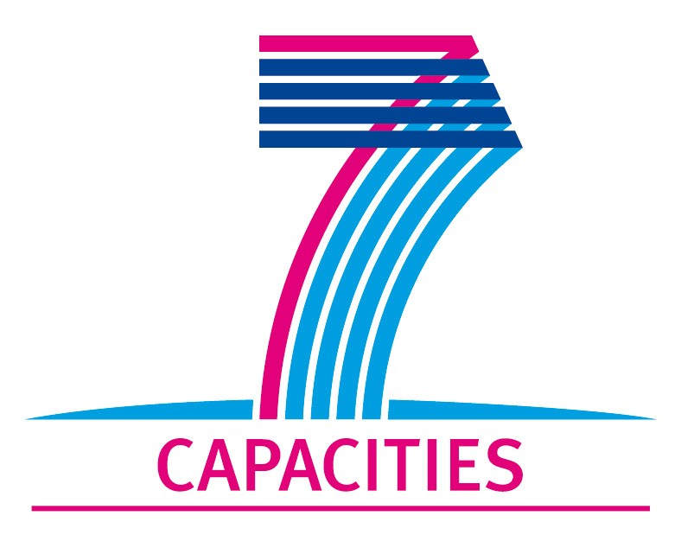
Application Form for MICROKELVIN Transnational Access Project

1. General Information

Project number: | Lancs05
Project Title: | Design of quartz tuning fork array for Quantum Turbulence Research
Lead scientist: | Title: | Prof.
 | First name: | Ladislav
 | Last name: | Skrbek
 | Birth date: | September 5, 1955
 | Passport number:
 | Research status/Position: | Leader of the Low Temperature Group
 | New User: | Yes
 | Scientific Field: | Quantum turbulence, Low temperature physics
 | Home institution: | Professor, Head of the Low Temperature Department, Faculty of Mathematics and Physics, Charles University in Prague, Czech Republic
 | Is your home institution MICROKELVIN partner? | no
 | Business address:
 | Street: | V Holešovičkách 2
 | PO Box:
 | City: | Prague
 | Zip/Postal Code: | 18000 Prague 8
 | Country: | Czech Republic
 | Telephone: | +420 22191 2558
 | Fax: | +420 22191 2567
 | E-mail: | Skrbek@fzu.cz
Curriculum vitae (18 lines max):
Born: Jilemnice, Czech Republic, September 5, 1955
Education: Moscow State University, Moscow, Russia; M.Sc. 1980; Ph.D. 1983 (Candidate of Sciences) (Advisors S.M. Chudinov, V.V. Moshchalkov), Charles University, Prague, Czech Republic, DrSc. 1997 (Doctor of Sciences), Professor of Condensed Matter Physics 2006
Positions: Institute of Physics, Czech Academy of Sciences, Low Temperature Department, Prague, Czech Republic: Researcher and Senior Researcher 1983-2002 ; Helsinki University of Technology, Low Temperature Laboratory, Otaniemi, Finland: Postdoctoral position 1985-1986 ; University of Birmingham, School of Physics and Astronomy, Birmingham, UK: Research Fellow 1991-1993 and 1994-1997 ;University of Oregon, Department of Physics, Eugene, Oregon: Research Professor 1997 –2000 ; Charles University, Faculty of Mathematics and Physics, Prague, Czech Republic: Deputy Head (2002-2008) and head (2008-)of the Low Temperature Department
Scientific interest and activity: Low temperature physics and fluid dynamics (classical and quantum turbulence, superfluidity and superconductivity, cryogenic fluid dynamics, cryogenics, low temperature NMR and thermometry)

 | Five most recent publications:
 | 1- D. Schmoranzer, M. Kráľová, V. Pilcová, W.F. Vinen and L. Skrbek: Experiments relating to the flow induced by a vibrating quartz tuning fork and similar structures in a classical fluid, Phys. Rev. E 81 066316 (2010)
 | 2- L. Skrbek: A Simple Phenomenological Model for the Effective Kinematic Viscosity of Helium Superfluids, Journal of Low Temp. Physics, 161 No3/4 555 (2010)
 | M. Sciacca, Y.A. Sergeev, C.F. Barenghi, L. Skrbek: Saturation of decaying counterflow turbulence in helium II, Phys. Rev. B 82 134531 (2010)3-
 | M. Šindler, R. Tesař, J. Koláček, L. Skrbek and Z. Šimša: Far infrared transmission of a superconducting NbN film, Phys. Rev. B 81 184529 (2010)4-
 | 5 M. Blažková, D. Schmoranzer, L. Skrbek, W.F. Vinen: Generation of Turbulence by Vibrating forks and other structures in superfluid He-4 Phys. Rev. B 79 No/5 054 522 (2009)-
Other participating scientists: | Name: |  | Position: | New User:2
 | 1-

2. Project Information

Name of host infrastructure: | Lancaster University
Access provider / Infrastructure Director: | Name: Prof. S. Fisher |  | E-mail address: s.fisher@lancaster.ac.uk
Planned project dates: | Start date: | 06/03/2011 | Completion date: | 17/03/2011
Project description (12 lines max):
Turbulence impacts on virtually every aspect of our everyday experiences, with enormous scientific and technological implications, but is still quite poorly understood. Superfluid He3 below 0.3Tc provides a unique environment for studying the fundamental principles of turbulence. Quantum turbulence in a superfluid consists of a tangle of vortex lines. In superfluid 3He, vortices can be non-invasively probed by ambient thermal excitations using Andreev reflection. Following its discovery 10 years ago, a great deal of progress has been made in this system. We now hope to extend these studies with turbulence visualisation measurements. For this purpose, large numbers of sensors are essential. Quartz tuning forks are well suited for this since they have very low intrinsic dissipation, small size and can be manufactured to tailored specifications. The ULT group at Lancaster has the necessary infrastructure and extensive expertise in studies of quantum turbulence in superfluid helium-3, whilst the Prague group has vast experience with quartz tuning forks. In this project, professor Skrbek will utilise this expertise to investigate tuning fork arrays for low temperature applications, such as ULT turbulence visualisation techniques.
Scientific objectives of the project (12 lines max):
Tuning fork arrays could have various applications in ULT physics. For instance, to perform the first Ultra-Low Temperature visualisation experiments on quantum turbulence in superfluid 3He, we hope to develop a quasiparticle detector containing an array of 20 tuning forks. The Lancaster group already have some custom made prototype arrays for this purpose. The technical requirements on the fork arrays make this project very demanding. The frequency of each tuning fork has to be uniquely defined and well separated from other those of all the other tuning forks to avoid interference/cross-talk between detectors. In order to resolve the turbulence images, the intrinsic damping of each fork has to be small compared to the quasiparticle damping in the superfluid. One obstacle to achieving this is the fork damping arising from sound emission. This has recently been studied by the Prague group. During this project, professor Skrbek will collaborate with the Lancaster ULT group to further study the effects of sound emission. He will analyse existing data obtained at Lancaster and will design and run additional test experiments to better determine the effects of sound emission on tuning fork arrays and to develop techniques to study this in more detail.
Technical description of work to be performed (20 lines max):
The Lancaster ULT group has recently purchased some prototype arrays of custom-manufactured quartz tuning forks which cover a wide range of frequencies from 6kHz to 160kHz. Substantial progress has also been made in developing the required measurement techniques to simultaneously drive and measure large numbers of forks in a single array. Such arrays are ideal for making a systematic study of the properties of tuning forks in quantum fluids, including sound emission. In this project, we will investigate the detailed properties of the individual tuning forks in the arrays. We will study their current – voltage characteristics, resonant frequencies and their intrinsic low temperature dissipation / quality factors. In particular we will study the frequency dependences of these quantities and compare measurements in vacuum and in liquid Helium to investigate the effects of sound emission. Some preliminary data has already made obtained. Following further analysis and comparison with the theoretical models and experimental data obtained by the Prague group, further measurements will be made to better understand the properties of tuning fork arrays. This will be very useful for future experiments and the knowledge gained will help to optimise the design (tuning fork geometries, resonant frequencies, and containing boxes) to produce tuning fork arrays suitable for Ultra-Low Temperature research, such quantum turbulence visualisation experiments in superfluid 3He.

3. Joint Proposals / Funding

Is this project in collaboration with other (concurrent) projects at the infrastructure? No
If yes, please specify:

Is this proposal submitted to any funding programmes? No
If yes, please specify:

____________________
The completed Application Form should be submitted to MICROKELVIN Management Office (Katariina@neuro.hut.fi, fax +358-9-47022969)

The lead scientist indicated here is expected to participate in the campaign as a user of the infrastructure.
Indicate ’Yes’ only if the user has never visited the infrastructure before this specific project, otherwise write ’No’.
Please list all participating user group members. Expand the table, if necessary.

